**实验1** **PostgreSQL数据库SQL语句实验指导**

实验类别：验证性 实验级别：必做

开课单位：计算机与软件学院 实验时数：12学时

一、实验目的：

1. 了解DBMS系统的功能、软件组成；

2、掌握利用SQL语句定义、操纵数据库的方法。

二、实验要求：

1、在课外安装相关软件并浏览软件自带的帮助文件和功能菜单，了解DBMS的功能、结构；  
 2、创建一个有两个关系表的数据库;

3、数据库、关系表定义；

4、学习定义关系表的约束(主键、外键、自定义)；

5、了解SQL的数据定义功能；

6、了解SQL的操纵功能；

7、 掌握典型的SQL语句的功能；

8、 了解视图的概念；

三、实验设备：

计算机、数据库管理系统、虚拟机等软件。

四、建议的实验步骤：

0、安装PostgreSQL软件。见附件1

1、使用SQL语句建立关系数据库模式及数据如下；（注：**数据要自己输入**）

EMP:

|  |  |  |  |  |  |  |  |
| --- | --- | --- | --- | --- | --- | --- | --- |
| EMPNO | ENAME | JOB | MGR | HIREDATE | SAL | COMM | DEPTNO |
| 7369 | SMITH | CLERK | 7902 | 17-Dec-90 | 13750 |  | 20 |
| 7499 | ALLEN | SALESMAN | 7698 | 20-FEB-89 | 19000 | 6400 | 30 |
| 7521 | WARD | SALESMAN | 7698 | 22-FEB-93 | 18500 | 4250 | 30 |
| 7566 | JONES | MANAGER | 7839 | 02-APR-89 | 26850 |  | 20 |
| 7654 | MARTIN | SALESMAN | 7698 | 28-SEP-97 | 15675 | 3500 | 30 |
| 7698 | BLAKE | MANAGER | 7839 | 01-MAY-90 | 24000 |  | 30 |
| 7782 | CLARK | MANAGER | 7839 | 09-JUN-88 | 27500 |  | 10 |
| 7788 | SCOTT | ANALYST | 7566 | 19-APR-87 | 19500 |  | 20 |
| 7839 | KING | PRESIDENT |  | 17-NOV-83 | 82500 |  | 10 |
| 7844 | TURNER | SALESMAN | 7698 | 08-SEP-92 | 18500 | 6250 | 30 |
| 7876 | ADAMS | CLERK | 7788 | 23-MAY-96 | 11900 |  | 20 |
| 7900 | JAMES | CLERK | 7698 | 03-DEC-95 | 12500 |  | 30 |
| 7902 | FORD | ANALYST | 7566 | 03-DEC-91 | 21500 |  | 20 |
| 7934 | MILLER | CLERK | 7782 | 23-JAN-95 | 13250 |  | 10 |
| 3258 | GREEN | SALESMAN | 4422 | 24-Jul-95 | 18500 | 2750 | 50 |
| 4422 | STEVENS | MANAGER | 7839 | 14-Jan-94 | 24750 |  | 50 |
| 6548 | BARNES | CLERK | 4422 | 16-Jan-95 | 11950 |  | 50 |

DEPT:

|  |  |  |
| --- | --- | --- |
| DEPTNO | DNAME | LOC |
| 10 | ACCOUNTING | LONDON |
| 20 | RESEARCH | PRESTON |
| 30 | SALES | LIVERPOOL |
| 40 | OPERATIONS | STAFFORD |
| 50 | MARKETING | LUTON |

2、用SQL定义数据库的关系表；

注：（每位同学在各自创建的图表名字后面添加自己学号以示区分，如EMP20170000112等）

3、定义各个关系的字段和自定义的数据完整性约束；

4、确定关系表的主键、外键；

5、对照帮助文件和教材理解主键和外键的约束规则；

6、分别为关系表添加记录；

7、理解SQL语句和关系运算的关系；

8、练习典型的SQL语句，对第6步实验中已建立的表做查询、插入、更新、删除等操作；完成练习题。

注：以上具体步骤可参见帮助文件SQL handbook 或相关书籍。

五、 实验1实验报告要求格式：

1、实验目的：

2、实验时间：

3、完成的实验内容：

4、实验设备和实验环境：

5、实验结果和结论（运行的结果）：

6、练习题：SQL Handbook练习题**EX1**，**老师会在实验课上选取难度较高的一些题目写入试验报告**。

**提交报告的详细内容和模板，请见实验报告模板。**

**附件：windows的PostgreSQL安装**

下载地址：<https://www.postgresql.org/download/windows/>

出现以下界面安装完成。

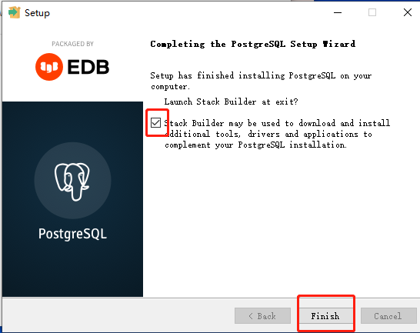

**【提醒：若出现stack builder页面 可直接选择cancel跳过】**

打开开始菜单查看以下内容完全即可：

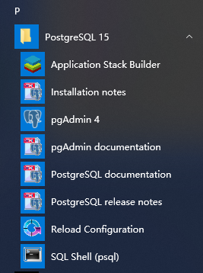

点pgAdmin4:

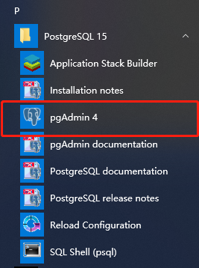

输入服务器密码配置链接：

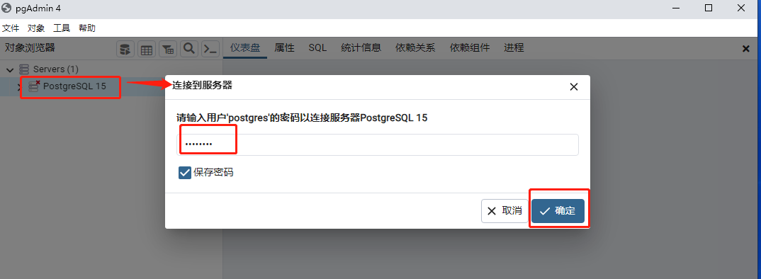

此时已经好了，可以开始创建数据库/表做测试。

**测试案例：**

**1/使用pgadmin4工具创建数据库**

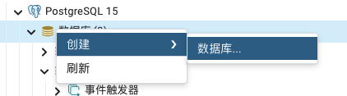

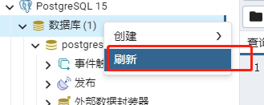

**2/使用pgadmin4工具创建数据表**

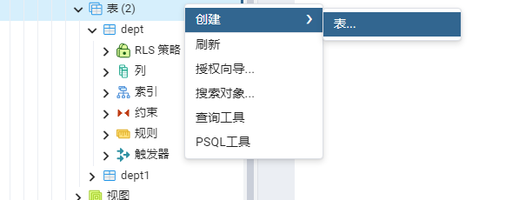

前两列信息填好

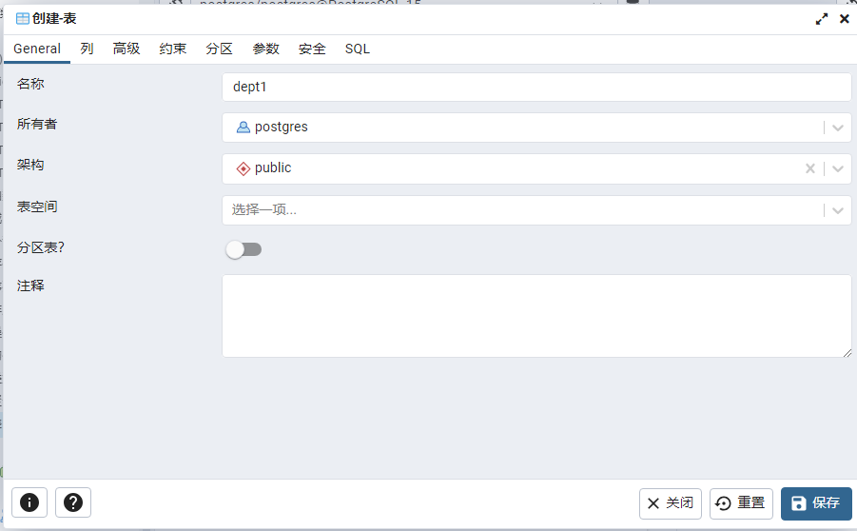

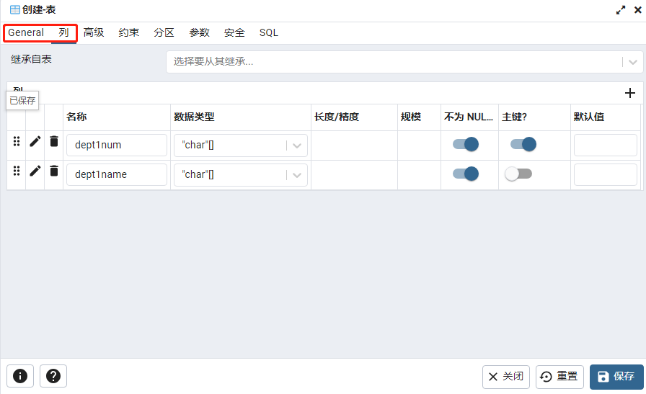

**【记得刷新】**



**3/sql语句创建数据库/表：**

创建数据库：

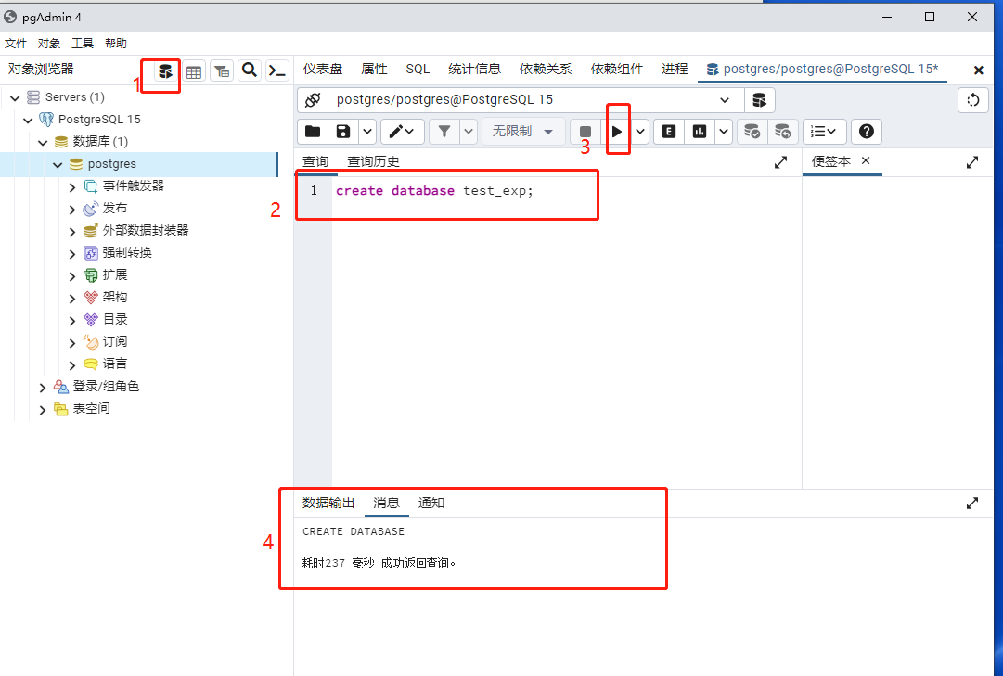

创建表：

参考语句：

|  |
| --- |
| create table emp  (  empno int not null  primary key,  ename char(10) null,  job varchar(10) null,  mgr varchar(5) null,  hierdate varchar(20) not null,  sal int null,  comm char(5) null,  deptno char(4) null,  constraint empno  unique (empno)  ); |

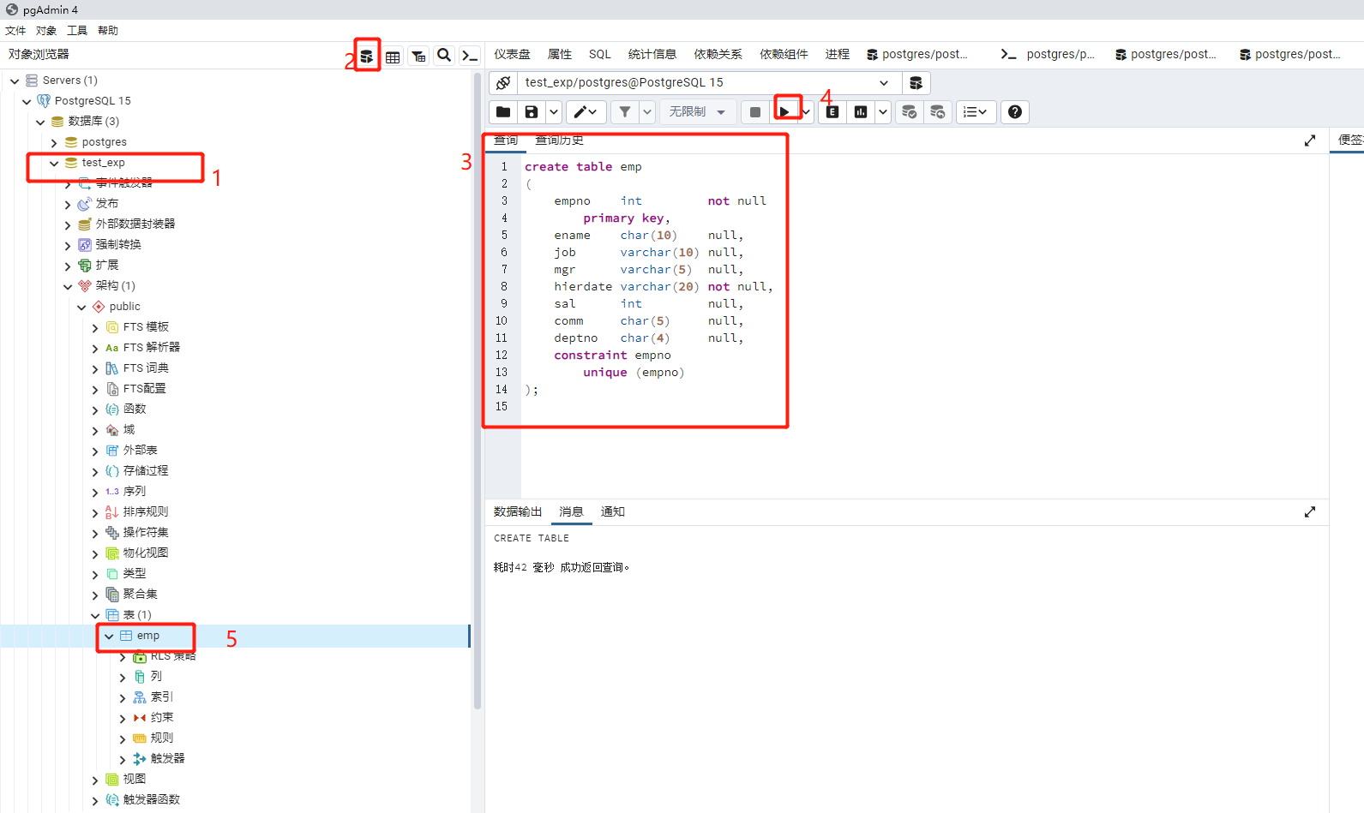

插入数据测试：

参考语句：

|  |
| --- |
| INSERT INTO emp (empno, ename, job, mgr, hierdate, sal, comm, deptno) VALUES (7369, 'smith', 'clerk', '7902', '17-dec-90', 13750, '', '20');  INSERT INTO emp (empno, ename, job, mgr, hierdate, sal, comm, deptno) VALUES (7499, 'allen', 'salesman', '7698', '20-Feb-89', 19000, '6400', '30'); |

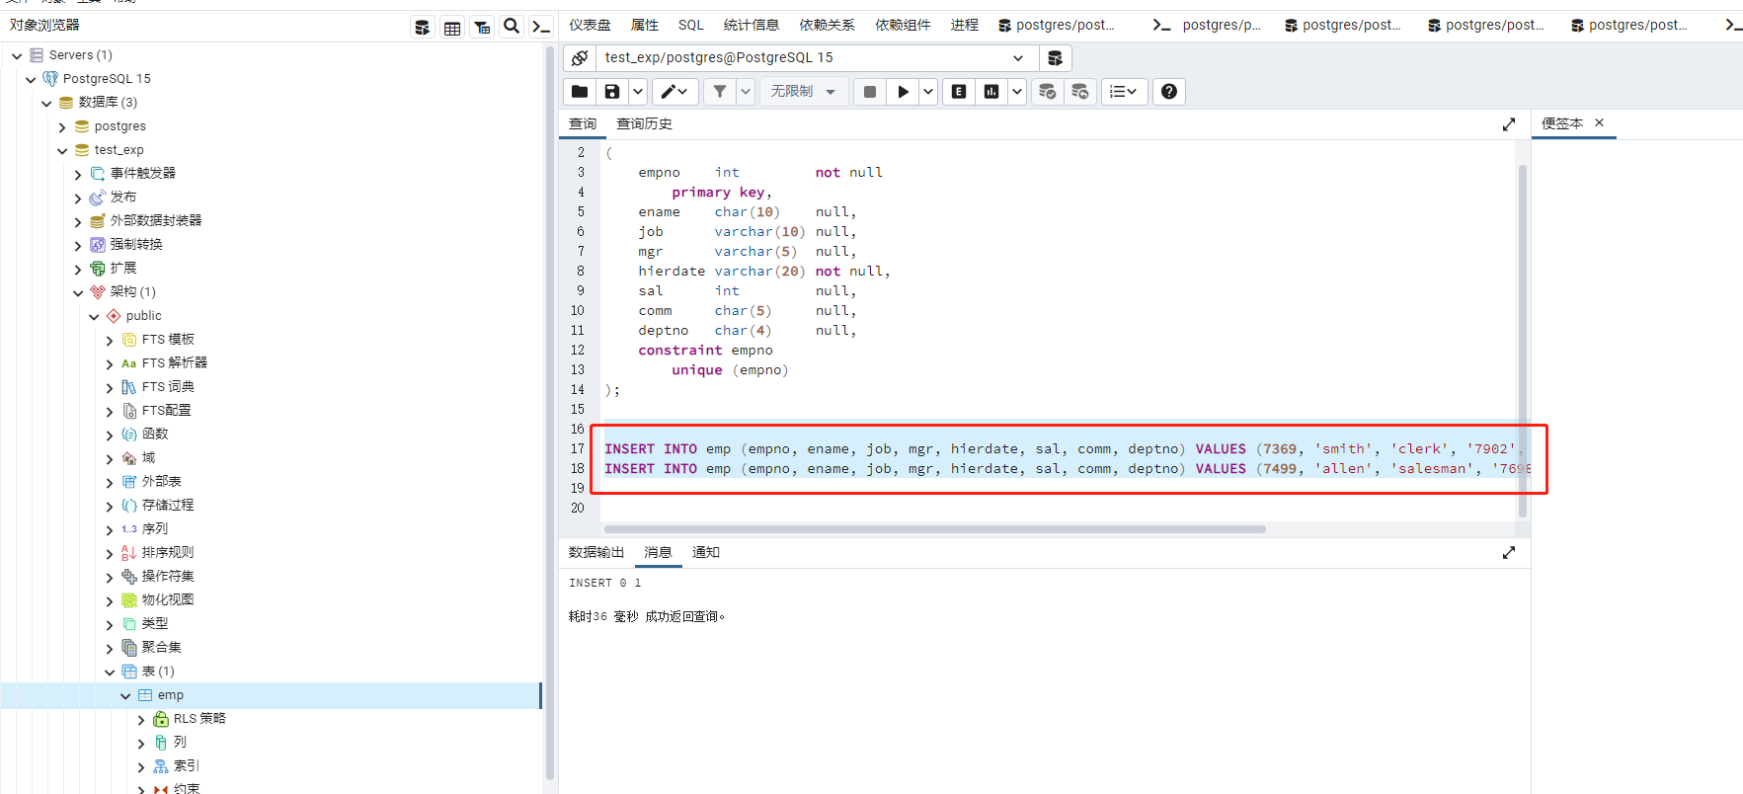

查看插入结果，可看到如图所示的表就是搞定了：

参考语句：

|  |
| --- |
| select * from emp； |

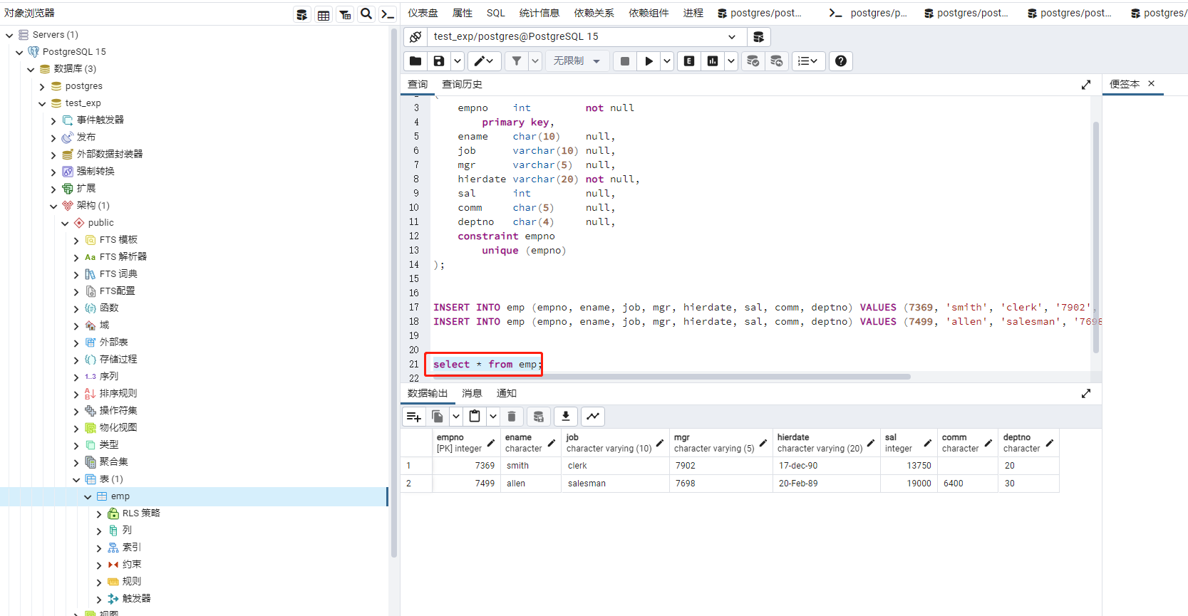

**4/psql命令同样可执行上述所有操作。可自己进行尝试。**

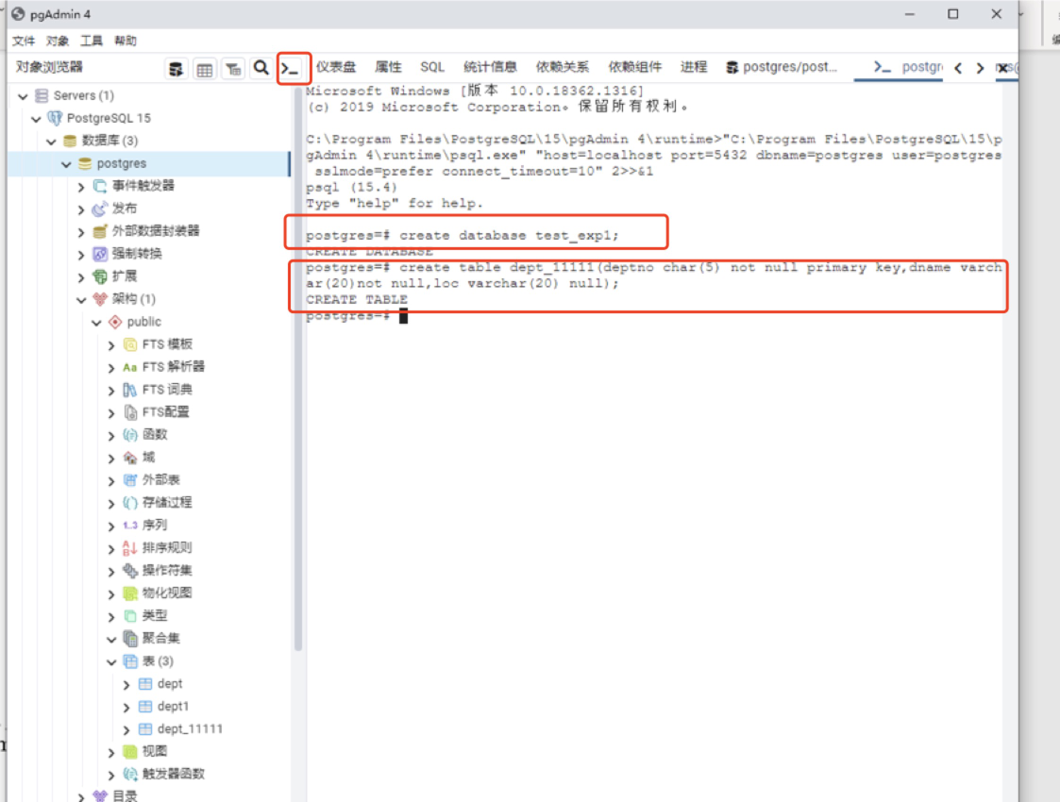

**其他附件：**

**附件一、CentOS7内PostgreSQL安装**

1. **源码编译安装与二进制安装（yum&rpm）**

系统环境准备

版本信息（举例）：

Redhat Enterprise 7.6（CentOS7）

PostgresSQL 12

编译环境要求：

make 版本3.8以上

GCC编译器(兼容C99)

解压命令tar

记录命令行操作包readline（没有该包无法使用方向键）

可选环境要求：

因为PostgreSQL支持服务器编程，因此可以根据需要安装需要的模块

如perl python tcl等

也可以启用本地语言支持NLS，该功能需要安装gettext

支持加密的客户端连接(需要安装openssl)使用服务支持验证(kerberos,openldap,pam)

准备包(需提前配置好yum源)

yum install -y \

libicu-devel.x86_64 \

icu.x86_64 \

perl-ExtUtils-Embed.noarch \

readline.x86_64 \

readline-devel.x86_64 \

zlib-devel.x86_64 \

openssl-devel.x86_64 \

pam-devel.x86_64 \

libxml2-devel.x86_64 \

libxslt-devel.x86_64 \

systemd-devel.x86_64 \

python36.x86_64 \

python36-devel.x86_64 \

openldap.x86_64 \

openldap-devel.x86_64 \

docbook*

**系统设置**

关闭防火墙

[root@sdedu ~]# systemctl  stop firewalld

[root@sdedu ~]# systemctl  disable firewalld

#如果不关闭防火墙，则将postgres 端口服务添加至防火墙中

[root@sdedu ~]# firewall-cmd  --add-port=5432  --permanent

关闭Selinux

#会话及关闭

[root@sdedu ~]# setenforce 0

#永久关闭

[root@sdedu ~]# sed -i "s/SELINUX=enforcing/SELINUX=disabled/g" /etc/selinux/config

配置资源限制

[root@sdedu ~]# cat /etc/security/limits.conf  | tail -6

postgres soft nofile 4096

postgres hard nofile 65536

postgres soft nproc 2048

postgres hard nporc 16384

postgres soft stack 10240

postgres hard stack 65536

注释：

#nofile 最大能打开的文件描述符

#nproc 最大的进程数

#stack 最大栈空间大小(单位为KB)

**源码编译安装**

源码安装通常可以根据自己的要求完成定制化的安装，如目录规划，内存大小，日志大小，脏块缓存大小及实现PostgreSQL支持的PL/tcl pl/perl pl/python等服务器过程化编程语言等等，以根据业务调整安装配置参数来提高服务器性能和充分利用服务器资源。具体步骤如下：

1 上传包至服务器/root/pack目录

[root@sdedu pack]# ls postgresql-12.0.tar.bz2

postgresql-12.0.tar.bz2

2 创建postgres用户并授权压缩包权限

   由于postgresql的启动停止等命令只能使用postgres用户操作，因此必须要创建postgres用户

[root@sdedu ~]# useradd -u 2000 postgres

[root@sdedu ~]# chown postgres:postgres pack/postgresql-12.0.tar.bz2

#移动 postgresql-12.0.tar.bz2 包到 /home/postgres用户下

[root@sdedu ~]# mv pack/postgresql-12.0.tar.bz2  /home/postgres/

3 切换到postgres用户，并解压源码包

[root@sdedu ~]# su - postgres

[postgres@sdedu ~]$ tar -jxf postgresql-12.0.tar.bz2

4 进入到解压目录

[postgres@sdedu ~]$ cd postgresql-12.0/

[postgres@sdedu postgresql-12.0]$ ll

5 创建PostgreSQL用户的安装目录并授权

   切换到root用户执行下列命令

[root@sdedu ~]# mkdir -p /data/pgsql/

[root@sdedu ~]# chown postgres.postgres -R /data/

6 执行configure预先检测配置环境

   以下操作都以postgres用户进行

#切换至 postgres用户并进入到源码解压目录

./configure \

--prefix=/data/pgsql/ \  #准备安装路径

--exec-prefix=/data/pgsql/exec \ #定义安装结构路径

--bindir=/data/pgsql/bin \ #定义PostgreSQL 相关服务命令

--sysconfdir=/data/pgsql/etc \ #定义系统配置目录

--libdir=/data/pgsql/exec/lib \ #定义相关库和动态库目录

--includedir=/data/pgsql/include \ #定义支持C 和 C++ 支持的头文件

--datarootdir=/data/pgsql/share \ #定义可供数据库只读的根目录

--datadir=/data/pgsql/share/data \ #定义可以数据库制度的目录

--localedir=/data/pgsql/share/locale \ #定义域目录

--mandir=/data/pgsql/share/man \ #定义 man 帮助手册目录

--docdir=/data/pgsql/share/doc/postgresql \ #定义 doc 格式帮助文档

--htmldir=/data/pgsql/share/html \ #定义html 格式帮助文档

--enable-nls="zh_CN" \ #定义主机支持的语言环境

--with-pgport=5432 \ #定义数据库服务的监听端口

--with-perl \ #启用支持 pl/perl 的服务器编程语言

--with-python \ #启用支持 pl/python 的服务器编程语言

--with-tcl \ #启用支持 pl/tcl 的服务器编程语言

--with-icu \ #启用支持 icu 的动态库

--with-openssl \ #启用支持 ssl（安全套接层） 连接

--with-pam \ #启用支持PAM认证模块

--with-ldap \ #启用支持轻量级访问目录数据库

--with-systemd \ # 启用 systemd 服务器

--with-readline \ #启用支持命令行记录功能

--with-libxml \ #启用 SQL 支持的XML 功能

--with-libxslt \ #启用 SQL 支持的 XML2 的依赖

--with-segsize=2 \ #配置段大小，默认数据文件段大小为 1G

--with-blocksize=8 \ #配置数据块的I/O大小

--with-wal-blocksize=8 #配置 wal 块的I/O大小

7 执行编译并安装

[postgres@sdedu ~]$ export COPT='-Werror'

#执行编译，-j 表示使用多job编译，受限于CPU核数和线程数

[postgres@sdedu ~]$ make all -j16

#如果要build 所有可用build的内容(html 和man 以及contrib等)使用如下

make world –j16

#编译安装

make install –j16

#如果需要安装手册帮助文档，执行

make install-docs –j16

#如果使用全局编译操作，那么使用

make install-world –j16

8 导入PostgreSQL lib库

[postgres@sdedu ~]$ export LD_LIBRARY_PATH=/data/pgsql/exec/lib

导入PostgreSQL的命令可执行路径

[postgres@sdedu ~]$ export PATH=/data/pgsql/bin:$PATH

导入MAN帮助信息

[postgres@sdedu ~]$ export MANPATH=/data/pgsql/share/man

为方便起见，将以上环境变量写入到/data/pgsql/exec/postgresql.env中

[postgres@sdedu ~]$ cat >> /data/pgsql/exec/postgresql.env <<EOF

> export LD_LIBRARY_PATH=/data/pgsql/exec/lib

> export PATH=/data/pgsql/bin:\$PATH

> export MANPATH=/data/pgsql/share/man

> EOF

然后将该文件添加到/home/postgres/.bash_profile中,并重新读取环境变量

9 初始化数据目录

pg_ctl -D /data/pgsql/pgdata/ initdb

或者

initdb -D /data/pgsql/pgdata

10 启动数据库

[postgres@sdedu ~]$ pg_ctl  start -D /data/pgsql/pgdata/ -l /tmp/logfile

注意，启动停止数据库必须使用 postgres 用户执行

11 登录数据库

[postgres@sdedu ~]$ psql -U postgres -d postgres

如果使用root用户登录数据库，则在/root/.bash_profile中配置PostgreSQL的环境变量(不建议这样做)

12 停止数据库

[postgres@sdedu ~]$ pg_ctl  stop -D /data/pgsql/pgdata/ -l /tmp/logfile ile

至此，PostgreSQL 12源码编译安装完成，现在既可以在数据库中执行各种符合规范的操作。

13 配置postgresql系统服务控制单元和开机启动

配置该服务之后，Redhat Linux就可以使用 systemctl系统控制命令来启动PostgreSQL数据库了。

使用root用户切换到 /usr/lib/systemd/system目录，编辑postgresql-12.service文件，该文件默认不存在，需要手动编辑，如下：

[root@sdedu system]# cat postgresql-12.service

[Unit]

Description=PostgreSQL database server

After=network.target

[Service]

Type=forking

User=postgres

Group=postgres

Environment=PGPORT=5432

Environment=PGDATA=/data/pgsql/pgdata

OOMScoreAdjust=-1000

ExecStart=/data/pgsql/bin/pg_ctl start -D ${PGDATA} -s -o "-p ${PGPORT}" -w -t 300

ExecStop=/data/pgsql/bin/pg_ctl stop -D ${PGDATA} -s -m fast

ExecReload=/data/pgsql/bin/pg_ctl reload -D ${PGDATA} -s

TimeoutSec=300

[Install]

WantedBy=multi-user.target

然后执行下列命令启用服务控制守护

[root@sdedu init.d]# systemctl  daemon-reload

使用systemctl系统服务控制命令启动postgresql

[root@sdedu ~]# systemctl  start postgresql-12.service

**rpm安装**

目前的Linux 7的发行版本已经集成了PostgreSQL 的相关套件，只需要配置好yum源既可以使用 yum 软件安装命令安装，系统自带的postgresql的版本为9.2版本。

1 配置本地yum

[root@sdedu ~]# cat /etc/yum.repos.d/local.repo

[local]

name=local

baseurl=file:///mnt

enabled=1

gpgcheck=0

2 更新yum源

[root@sdedu ~]# yum clean all && yum repolist all

3 检查PostgreSQL相关软件套件

[root@sdedu yum.repos.d]# yum list all | grep ^postgresql

4 执行yum安装

[root@sdedu ~]# yum install -y postgresql-server.x86_64

使用yum安装后，默认的命令路径位于/usr/bin下

5 初始化数据目录

#创建初始化数据目录

[root@sdedu ~]# mkdir -p /pg92/pgdata/data/

#为数据目录授权 postgres 用户所属主和所属组

[root@sdedu ~]# chown postgres.postgres -R /pg92

#切换至 postgres 用户

[root@sdedu ~]# su – postgres

#执行 初始化数据库命令

[postgres@sdedu ~]$ /usr/bin/initdb  -D  /pg92/pgdata/data/

6 启动数据库

[postgres@sdedu ~]$ /usr/bin/pg_ctl start -D /pg92/pgdata/data/ -l /tmp/logfile

server starting

7 配置服务开机启动

[root@sdedu ~]# systemctl enable postgresql.service

Yum安装配置相对于简单，可以作为学习入门

8 拓展

除了使用操作系统本身集成的postgresql软件套件外，也可以通过官方网站获取官方集成的rpm软件套件，下去可自行尝试，在Linux下下载必须要保证网络畅通。

具体下载地址：

<https://download.postgresql.org/pub/repos/yum/reporpms/EL-7-x86_64/pgdg-redhat-repo-latest.noarch.rpm>

下载官方提供的 rpm 源配置包

然后使用rpm 安装该包

[root@sdedu ~]# rpm -ivh pgdg-redhat-repo-latest.noarch.rpm

或者直接使用yum进行安装

[root@sdedu ~]# yum install https://download.postgresql.org/pub/repos/yum/reporpms/EL-7-x86_64/pgdg-redhat-repo-latest.noarch.rpm

然后执行yum安装客户端

[root@sdedu ~]# yum install postgresql12

执行yum安装数据库服务端

[root@sdedu ~]# yum install postgresql12-server

初始化数据目录

[root@sdedu ~]# /usr/pgsql-12/bin/postgresql-12-setup initdb

通过systemctl启动数据库和配置开机启动

[root@sdedu ~]# systemctl  start postgresql-12

[root@sdedu ~]# systemctl  enable postgresql-12

1. **源码安装设置开机自启动**

方式一：

以下过程在redhat 7.4环境得到验证！

设置PostgreSQL开机自启动

PostgreSQL的开机自启动脚本位于PostgreSQL源码目录的contrib/start-scripts路径下

这个路径是安装包解压完的路径。

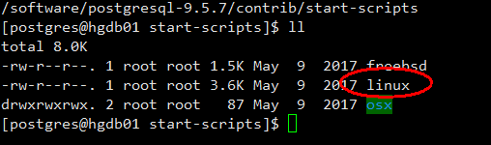

linux文件即为linux系统上的启动脚本

1）修改linux文件属性，添加X属性

exit

切换到root用户

cd /software/postgresql-9.5.7/contrib/start-scripts 切换到解压目录下

chmod a+x linux

2) 复制linux文件到/etc/init.d目录下，更名为postgresql

cp linux /etc/init.d/postgresql

3）修改/etc/init.d/postgresql文件的两个变量

vi /etc/init.d/postgresql

prefix设置为postgresql的安装路径：prefix=/usr/local/pgsql957

PGDATA设置为postgresql的数据目录路径：PGDATA="/pgdata/data"

4) 执行service postgresql start，就可以启动PostgreSQL服务

service postgresql start

5）设置postgresql服务开机自启动

chkconfig --add postgresql

执行上面的命令，就可以实现postgresql服务的开机自启动。

Reboot

方式二：

环境概要：

版本信息：Redhat Enterprise 7.6

PostgresSQL 12

编译环境要求：

make 版本3.8以上

GCC编译器(兼容C99)

解压命令tar

记录命令行操作包readline（没有该包无法使用方向键）

配置postgresql系统服务控制单元和开机启动

配置该服务之后，Redhat Linux就可以使用 systemctl系统控制命令来启动PostgreSQL数据库了。

使用root用户切换到 /usr/lib/systemd/system目录，编辑postgresql-12.service文件，该文件默认不存在，需要手动编辑，如下：

[root@sdedu system]# cat postgresql-12.service

[Unit]

Description=PostgreSQL database server

After=network.target

[Service]

Type=forking

User=postgres

Group=postgres

Environment=PGPORT=5432

Environment=PGDATA=/data/pgsql/pgdata

OOMScoreAdjust=-1000

ExecStart=/data/pgsql/bin/pg_ctl start -D ${PGDATA} -s -o "-p ${PGPORT}" -w -t 300

ExecStop=/data/pgsql/bin/pg_ctl stop -D ${PGDATA} -s -m fast

ExecReload=/data/pgsql/bin/pg_ctl reload -D ${PGDATA} -s

TimeoutSec=300

[Install]

WantedBy=multi-user.target

然后执行下列命令启用服务控制守护

[root@sdedu init.d]# systemctl  daemon-reload

使用systemctl系统服务控制命令启动postgresql

[root@sdedu ~]# systemctl  start postgresql-12.service

1. **psql的使用**

### 1.psql基本命令练习

使用帮助：

psql --help

# \? 全局帮助

# \h \help SQL命令帮助

# \h CREATE USER 具体SQL语句使用帮助

psql -E参数，可以把psql中各种以\开头的命令执行的实际SQL打印出来。

\set ECHO_HIDDEN on|off 打开|关闭 命令实际执行的SQL，和-E类似。

连接实例

psql -U username -h hostname

创建用户

CREATE USER user_t WITH ENCRYPTED PASSWORD '123456';

*使用 c:\pgdata 文件夹作为缺省表存储空间*

*如果在多用户环境下运行POSTGRESQL服务器，则需要对C:\pgdata文件夹设置安全使用权限*

*创建名为“tbsp_1”的表空间：*

*CREATE TABLESPACE tbsp_1 OWNER <db_owner> LOCATION 'c:/pgdata/sampledb/system';*

*检验创建的表空间*

*\db+ <sample_db>*

*创建 “sample_db”数据库：*

*CREATE DATABASE <sample_db> OWNER <db_owner> TEMPLATE template0 TABLESPACE tbsp_1;*

*CREATE DATABASE testdb OWNER postgres TEMPLATE template0 TABLESPACE tbsp_1;*

*创建数据库(指定数据库所有者)*

*CREATE DATABASE hello WITH OWNER neo123;*

*修改数据库名称*

*ALTER DATABASE hello RENAME TO hello1;*

*删除用户(如果用户是某数据库的owner，那先得删除数据库)*

*DROP DATABASE hello;*

*DROP USER neo123;*

\q 退出数据库控制台

列表查看所有已安装的数据库

\l+

连接数据库

\c <sample_db_name>

查看当前连接的数据库名称

select current_database();

查看当前连接的用户名：   
select * from current_user   
select user;

列表浏览数据库实体对象

\d+

检验所创建的拥有者

\du <db_owner>

### 2.psql工具访问数据库

psql是PostgreSQL自身提供的一款查询工具，无论哪种操作系统平台下，该工具都可用，并且使用方法都是一致的。

psql有两大功能，除了作为交互查询工具使用之外，psql还是一款理想的脚本工具。

#默认会连接到本地库postgres（安装完后默认生成）

psql

#列表查看所有已安装的数据库

\l+

#查看版本信息

select version();

#查看当前数据库

select current_database();

#连接数据库postgres

\c postgres

\conninfo #显示连接信息

#我们假设psql有权访问PostgreSQL服务器，所有连接参数都是缺省的，但是现实中并非总是这样。我们当前的连接参数如下所示：

psql -h hostname -p 5866 -d dbname -U username -W

#查看版本信息

psql -V

#执行sql文件

psql s.sql-f example

psql -x -f examples.sql

#使用psql执行sql命令

psql -c "select current_time"

psql元命令

#查看命令执行的时间

\timing on

可执行以下sql查看效果

SELECT COUNT(*) FROM pg_tables;

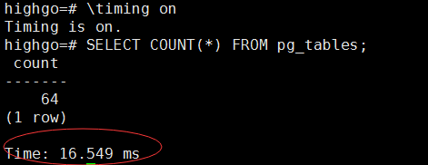

#默认情况下的自动提交时启用的，要设置自动提交关闭

\set autocommit off

#退出psql环境

ctl +z 快捷键 或者 \q

附：

以"\"开头，跟命令动词，跟参数

\? 显示psql下命令

\c dbname [username]连接新数据库

\cd [dir] 改变当前工作目录

\d [name] 列出数据库中的表/索引/视图/，声明了table则列出字段

\e [filename] 编辑文件 \E [filename] 编辑文件结束后执行

\g [{filename | command}] 当前查询输出到filename或用以执行command

\h [command] 给出SQL命令的语法帮助

\i filename 从文件filename中读取查询到输入缓冲

\l 列出所有数据库

\du 列出所有用户

\di 列出索引

\dn 列出Schema

\dp 列出表

\o [{filename | command}] 将后面查询结果输出到filename或用以执行command

\q 退出psql

\x命令

------

\x命令可以将表中的每一行的每列数据都拆分为单行显示，也就是将每条记录（一条记录就是一行）中的每一列都显示在一行里面，以记录为单位进行显示

$ \x #全局设置，一次会改变显示，再在shell中输入\x就退回到原来的显示

tab补齐功能也是非常有帮助的，因为只要按下TAB键，程序就会帮我们完成后面的语法部分。

#将执行sql的错误结果信息写入日志文件

psql -p16432 -Uadmin -dbenchmarksql -f test.sql -a -b -e&>test.log

### 3.psql中设置命令别名

使用\set为某个命令创建别名，可以将全局的别名写到psqlrc文件中。

#定义查询sql语句别名

\set SIZE 'SELECT pg_size_pretty(pg_table_size(''t'')) table_size, pg_size_pretty(pg_indexes_size(''t'')) index_size;’

#调用别名

:SIZE

### 示例

### psql 访问数据库的密码验证

psql 访问数据库涉及5个要素：

-U 用户名

-W 交互方式输入密码

-h 主机名

-p 端口号

-d 数据库名

一般客户端访问需要设置以上5个要素，类似于Oracle客户端 tnsnames.ora文件中的相关设定。

服务端通过psql访问数据库如果不设置，通常会查找用户环境变量的相关设置（譬如.bash_profile文件或创建的.mylocalenv文件）。

当然验证过程要收到pg_hba.conf文件的限制；要不要输入密码关联 method字段值md5或trust（可信的不需要密码验证）。

另外，需要说明的一点是：-W选项的含义是需要以交互的方式输入密码，而不是在选项后边直接输入明文密码，区别于Oracle 或DB2的输入密码明文，主要是出于安全性的考虑。

：

[postgres@PostgreSQL01 data]$ vi pg_hba.conf

# TYPE DATABASE USER ADDRESS METHOD

# "local" is for Unix domain socket connections only

local all all md5

host all postgres 192.168.137.0/24 md5

host all all ::1/128 md5

[postgres@PostgreSQL01 data]$ psql -U postgres -W -h localhost -d testdb -p 1921

Password for user postgres: #此处交互式输入密码

psql (9.5.7)

Type "help" for help.

testdb=# \q

这里的-u -p -d选项都可以省略，因为环境变量有所设置！

[postgres@PostgreSQL01 data]$ cat ~/.bash_profile

PATH=$PATH:$HOME/.local/bin:$HOME/bin

export PATH

#add

export PGPORT=1921

export PGDATA=/pgdata/data

export LANG=en_US.utf8

export PGHOME=/usr/local/pgsql957

export LD_LIBRARY_PATH=$PGHOME/lib:/lib64:/usr/lib64:/usr/local/lib64:/lib:/usr/lib:/usr/local/lib:$LD_LIBRARY_PATH

export DATE=`date +"%Y%m%d%H%M"`

export PATH=$PGHOME/bin:$PATH:.

export MANPATH=$PGHOME/share/man:$MANPATH

export PGUSER=postgres

export PGHOST=$PGDATA

export PGDATABASE=testdb

alias rm='rm -i'

alias ll='ls -lh'

[postgres@PostgreSQL01 data]$ psql -U postgres

Password for user postgres: #此处交互式输入密码

psql (9.5.7)

Type "help" for help.

### psql切换数据库和用户

使用psql怎么切换数据库或者用户呢？

通过如下方式可以通过特定用户连接特定数据库：

[postgres@rhel ~]$ psql -d postgres -U postgres

-d就是指定的数据库名，-U就是指定的用户名。

如果通过psql已经连接进来了，我们可以怎么切换呢？

通过如下方式：

postgres=# \c postgres xyh

Password for user xyh:

You are now connected to database "postgres" as user "xyh".

postgres=>

通过\c，后跟数据库和用户名。

\c后什么都不写会显示当前连接信息：

postgres=> \c

You are now connected to database "postgres" as user "xyh".

### psql 编辑执行脚本文件

1. 准备sql脚本文件tmp.sql

create table public.stu(id int,name varchar);

Insert into public.stu values(1,'a');

Insert into public.stu values(2,'a');

Insert into public.stu values(3,'a');

Insert into public.stu values(4,'a');

1. 演练以下元命令

\e #编辑脚本文件

#执行脚本文件的方法有以下几种方式，效果相同

\i /home/postgres/tmpscript/tmp.sql

psql -f /home/postgres/tmpscript/tmp.sql

psql < /home/postgres/tmpscript/tmp.sql

1. 演练输出重定向

\o /home/postgres/select.out #打开文件重定向输出

Select * from stu;

\o #关闭重定向文件

testdb=# \! cat /home/postgres/select.out

id | name

----+------

1 | a

2 | a

3 | a

4 | a

(4 rows)

### psql设置详细的打印输出

\set VERBOSITY verbose

postgres=# select a;

ERROR: column "a" does not exist

LINE 1: select a;

^

postgres=# \set VERBOSITY verbose

postgres=# select a;

ERROR: 42703: column "a" does not exist --可以报出问题的代码

LINE 1: select a;

^

LOCATION: errorMissingColumn, parse_relation.c:3293

### psql元命令与sql关系

一般地可以通过元命令查看模式等信息，参考命令如下：

通过以下元命令可以列出所有模式

\dn[S+] [PATTERN]

进而翻阅资料定位到系统表pg_namespace，参阅手册关于该系统表的描述如下：

pg_namespace:该系统表存储名字空间(模式)。

|  |  |  |  |
| --- | --- | --- | --- |
| **名字** | **类型** | **引用** | **描述** |
| nspname | name |  | 名字空间的名称。 |
| nspowner | oid | pg_authid.oid | 名字空间的所有者 |
| nspacl | aclitem[] |  | 访问权限。 |

见如下应用：    

#查看当前数据库public模式的创建者的名称。  
postgres=#SELECT nspname,rolname FROM pg_namespace n, pg_authid a WHERE nspname = 'public' AND nspowner = a.oid;

nspname | rolname

---------+---------

public | postgres

(1 行记录)

这里有个名字空间的概念，对比其它关系数据库比较新颖，通过以上可以确定是名字空间即为模式名。

两种方法如下：

psql -E 参数，可以把psql中各种以\开头的命令执行的实际SQL打印出来。

\set ECHO_HIDDEN on|off 打开|关闭 命令实际执行的SQL，和-E类似。

设置后再次调用元命令\dnS+查看模式信息 ，显示如下：

postgres=# \set ECHO_HIDDEN on

postgres=# \dnS+

********* 查询 **********

SELECT n.nspname AS "Name",

pg_catalog.pg_get_userbyid(n.nspowner) AS "Owner",

pg_catalog.array_to_string(n.nspacl, E'\n') AS "Access privileges",

pg_catalog.obj_description(n.oid, 'pg_namespace') AS "Description"

FROM pg_catalog.pg_namespace n

ORDER BY 1;

**************************

架构模式列表

名称 | 拥有者 | 存取权限 | 描述

--------------------+--------+------------------+------------------------------------------------------

hgdb_catalog | postgres | postgres=UC/postgres+| postgres Database catalog schema

| | =U/postgres |

information_schema | postgres | postgres=UC/postgres+|

| | =U/postgres |

oracle_catalog | postgres | postgres=UC/postgres+| postgres Database catalog schema(Oracle compatibility)

| | =U/postgres |

pg_catalog | postgres | postgres=UC/postgres+| system catalog schema

| | =U/postgres |

pg_temp_1 | postgres | |

pg_toast | postgres | | reserved schema for TOAST tables

pg_toast_temp_1 | postgres | |

public | postgres | postgres=UC/postgres+| standard public schema

| | =UC/postgres |

(8 行记录)

可以看到元命令调用的sql访问的系统表正是pg_catalog.pg_namespace，从而验证了模式创建后存放在了此系统表中。

重要的是，通过此种方法可以获取到其它元命令执行的sql 从而获取更多数据库管理信息。

**附件二、SQLhandbook**

**CONTENTS**

**p 2-3 Introduction - PLEASE READ**

**4 Logging in and out**

**5-6 Editing SQL statements**

**6 SAVE commands**

**7 Running files. The SPOOL command**

**8 SELECT data**

**9 Creating the tables you need**

**10 The Data for the examples**

**11-16 The Basic SELECT statement**

**17-18 Exercise 1**

**19 JOINing tables**

**20 Joining a table to itself**

**21-22 Outer Joins**

**23 Exercise 2**

**23-7 SQL functions**

**28-33 Group Functions**

**34 Exercise 3**

**35-7 Date Functions**

**38 Exercise 4**

**39-40 GROUP BY**

**41-42 The HAVING clause**

**43 Exercise 5**

**44-49 Subqueries**

**50 Exercise 6**

**51-65 Adding, Updating and Deleting data,data types and views**

**66 Exercise 7**

**67-71 Set Operators and Logical Operators**

**This book has been designed to help you learn SQL as it has to be learnt by doing, not by teaching.**

**It is therefore in your best interest to work your way through it (10-15 hours work) systematically.**

**You may be asked to submit some of the answers to the exercises, for an assignment and may be asked specific details in an exam.**

SQL (Structured Query Language) is a relational database language. Amongst other things the language consists of statements to insert, update, query and protect data. Although SQL is not a DBMS, for simplicity in this manual SQL will be considered as a DBMS as well as a language. Of course, in the places where it is necessary, a distinction will be drawn.

There are a few things to note about SQL as a database language, because it is a relational database language, SQL may be grouped with the non-procedural database languages. By non-procedural it is meant that users (with the help of the various statements) have only to specify which data they want and not how this data must be found. C++, Java and VB are examples of Procedural languages. It also means that there are no variables, IF statements or loop constructs. Because it is non procedural, it is very difficult to teach, and the only way to learn it is by working through this book and picking up how certain results can be achieved.

SQL can be used in two ways. First, interpretively: an SQL statement is entered at a terminal or PC and immediately processed or interpreted. The result is also visible immediately. This is known as interactive SQL. The second way is known as embedded SQL. The SQL statements are embedded in a program written in another, procedural language. Results of these statements are not immediately visible to the user, but are processed by the 'enveloping' program. In this module we shall be assuming the interpretive use of SQL.

SQL has already been implemented by many manufacturers as the database language for their DBMS. It is not the case, therefore, that SQL is the name of a particular manufacturer's product available on the market today. However, it is the market standard and you will find many career opportunities within the general SQL field. Currently it is number one in the Jobs market.

Some manufacturers are now providing SQL-server machines. These machines can be connected to a DBMS, and they carry out all the database functions defined in SQL. Thus SQL is now a data interchange language between any systems that can 'speak' SQL. Typically, an SQL-server is placed on a LAN where it processes all database operations for clients on the LAN.

Please note that, although SQL is an ISO standard, each manufacturer have their own add-ons.

**SELECTING DATA FROM TABLES.**

The SELECT Command is the basis of all queries on tables, therefore its full description is given to show its power. Examples of the various formats are provided after the description.

SELECT

    column_1, column_2, ...

FROM

    table_1

[INNER | LEFT |RIGHT] JOIN table_2 ON conditions

WHERE

    conditions

GROUP BY column_1

HAVING group_conditions

ORDER BY column_1

LIMIT offset, length;

The SELECT statement consists of several clauses as explained in the following list:

* SELECT followed by a list of comma-separated columns or an asterisk (*) to indicate that you want to return all columns.
* FROM specifies the table or view where you want to query the data.
* [JOIN](http://www.mysqltutorial.org/mysql-join/) gets related data from other tables based on specific join conditions.
* [WHERE](http://www.mysqltutorial.org/mysql-where/) clause filters row in the result set.
* [GROUP BY](http://www.mysqltutorial.org/mysql-group-by.aspx) clause groups a set of rows into groups and applies [aggregate functions](http://www.mysqltutorial.org/mysql-aggregate-functions.aspx) on each group.
* [HAVING](http://www.mysqltutorial.org/mysql-having.aspx) clause filters group based on groups defined by GROUP BY clause.
* [ORDER BY](http://www.mysqltutorial.org/mysql-order-by/) clause specifies a list of columns for sorting.
* [LIMIT](http://www.mysqltutorial.org/mysql-limit.aspx) constrains the number of returned rows.

The SELECT and FROM clauses are required in the statement.

Description: Selects rows and columns from one or more tables. May be used as a command, or (with certain restrictions on Clauses) as a subquery in another **SELECT**, and **UPDATE,** or other **SQL** command.

Don’t worry too much about this generic syntax list as you will see all kinds of examples throughout this book.

**PARAMETERS AND CLAUSES.**

**ALL**  makes **SELECT** display all rows produced by the query. Since this is the default, it is generally not needed

**DISTINCT**  makes it omit duplicate rows.

**\*** makes **SELECT**  display all columns of the table(s) specified by **FROM,** in the order they were defined when the table(s) were created.

i.e. **SELECT * FROM EMP;**

Alternatively, each expression becomes one column in the display.

i.e. **SELECT EMPNO, ENAME FROM EMP;**

displays only the named columns in the expression.

Each alias, if specified, is used to label the preceding expression in the displayed table.

**e.g. SELECT ENAME “Name”, SAL “Salary” from EMP;**

**Note the use of double quotes here. character strings are delimited by single quotes.**

**FROM** table specifies the table or view to be drawn on. More than one table implies a join. **Alias,** if specified, may be used as an alias for the preceding table through the rest of the **SELECT** command.

**SELECTED EXAMPLES AND WORKSHEETS.**

**The examples in this book should be worked through carefully to ensure that you understand what the commands are doing. Your assignment work will assume that knowledge.**

**You will need the following tables, EMP and DEPT.**

**These can be created with the following commands:**

**EPT;**

**The data in them is currently as shown on the next page:**

**Note - if the table contents become corrupted (particularly after the Update example in Exercise 7), you can always delete the tables and start again. This can be achieved by:**

**DROP TABLE EMP;**

**DROP TABLE DEPT;**

**To list all the tables in your Oracle area:**

**SHOW TABLES;**

**THE DATA USED IN THESE EXERCISES:**

**EMPNO ENAME JOB MGR HIREDATE SAL COMM DEPTNO**

**-------------------------------------------------------------------------------------------------------------------------------------**

**7369 SMITH CLERK 7902 17-DEC-90 13750 20**

**7499 ALLEN SALESMAN 7698 20-FEB-89 19000 6400 30**

**7521 WARD SALESMAN 7698 22-FEB-93 18500 4250 30**

**7566 JONES MANAGER 7839 02-APR-89 26850 20**

**7654 MARTIN SALESMAN 7698 28-SEP-97 15675 3500 30**

**7698 BLAKE MANAGER 7839 01-MAY-90 24000 30**

**7782 CLARK MANAGER 7839 09-JUN-88 27500 10**

**7788 SCOTT ANALYST 7566 19-APR-87 19500 20**

**7839 KING PRESIDENT 17-NOV-83 82500 10**

**7844 TURNER SALESMAN 7698 08-SEP-92 18500 6250 30**

**7876 ADAMS CLERK 7788 23-MAY-96 11900 20**

**7900 JAMES CLERK 7698 03-DEC-95 12500 30**

**7902 FORD ANALYST 7566 03-DEC-91 21500 20**

**7934 MILLER CLERK 7782 23-JAN-95 13250 10**

**3258 GREEN SALESMAN 4422 24-JUL-95 18500 2750 50**

**4422 STEVENS MANAGER 7839 14-JAN-94 24750 50**

**6548 BARNES CLERK 4422 16-JAN-95 11950 50**

**DEPTNO DNAME LOC**

**------- -------------- -------------------------------------------**

**10 ACCOUNTING LONDON**

**20 RESEARCH PRESTON**

**30 SALES LIVERPOOL**

**40 OPERATIONS STAFFORD**

**50 MARKETING LUTON**

**THE SELECT STATEMENT**

The **SELECT** statement is the workhorse of query processing the basic statement is:-

**SELECT** COLUMN(S) **FROM** TABLENAME;

This is the minimum amount of detail which must be entered for a **SELECT** statement to work.

**Try the following examples:-**

**SELECT * FROM emp;**

Provides a listing of all the data (all columns) in the EMP table.

**SELECT ename FROM emp;**

Gives a list of all the employee names found in the emp table.

**SELECT dname, loc FROM dept;**

gives department names and locations.

**SELECT job FROM emp;** (with duplicates)

Lists all the jobs in the emp table even if they appear more than once.

**SELECT DISTINCT job FROM emp;** (without duplicates)

List all the jobs in the EMP table eliminating duplicates.

**SELECT job, deptno FROM emp;** (with duplicates)

Lists the combination of jobs and departments for every row of the emp table.

**SELECT DISTINCT job, deptno FROM emp;** (without duplicates)

List all the combinations of job and department in the EMP table eliminating duplicates.

**THE WHERE CLAUSE**

A **WHERE** clause causes a 'search' to be made and only those rows that meet the search condition are retrieved.

A **WHERE** clause condition can use any of the following comparison operators:-

= equal to

**SELECT * FROM emp**

**WHERE ename = 'JONES';**

**(Again note that the data is case sensitive, this would not find Jones)**

!= not equal to

^= not equal to

<> not equal to

**SELECT * FROM emp**

**WHERE ename != 'FORD';**

> greater than

**SELECT * FROM emp**

**WHERE sal > 15000;**

>= greater than or equal to

**SELECT * FROM emp**

**WHERE sal >= 12000;**

< less than

**SELECT * FROM emp**

**WHERE sal < 15000;**

<= less than or equal to

**SELECT * FROM emp**

**WHERE sal <= 12000;**

or special SQL operators

**BETWEEN low AND high** (values are inclusive)

**SELECT * FROM emp**

**WHERE sal BETWEEN 10000 AND 15000;**

**IN (VALUE1, VALUE2, VALUE3......)** character strings must be enclosed in quotes

**SELECT * FROM emp**

**WHERE job IN ('CLERK', 'ANALYST');**

Selects all employees who are

Clerks or analysts

**LIKE 'string picture'** use '%' and '_' as wildcards within a string picture. Each _ acts for

one character.

**SELECT * FROM emp**

**WHERE ename LIKE '%A%';** % is for any number of characters

Selects all employees with an ‘A’

in their name.

**IS NULL** IS may only be used with NULL's

(this means the variable has no value)

and also **NOT** any of the above expressions (used for negation purposes).

**Try the following:-**

**SELECT ename, empno, deptno**

**FROM emp**

**WHERE job = 'CLERK';**

List the names, numbers and departments of all the Clerks.

**SELECT ename, sal, comm FROM emp**

**WHERE comm > sal;**

Find the employees whose commission is greater than their salary.

**SELECT ename, job, sal FROM emp**

**WHERE sal BETWEEN 12000 AND 14000;**

Finds all employees who earn between 12,000 and 14,000

Selecting rows within a range, the WHERE clause can have a low-value and a high-value associated with it, these values represent the bottom and top of the required range.

**NOT BETWEEN** means that only rows that are outside the range will be selected.

**SELECT ename FROM emp**

**WHERE job IN ('CLERK', 'ANALYST', 'SALESMAN');**

Finds the employees who are clerks, analysts or salesmen.

**NOT IN** would list those employees whose jobs are not in the list.

**SELECT ename FROM emp**

**WHERE job NOT IN ('CLERK', 'ANALYST', 'SALESMAN');**

**SELECT ename, deptno FROM emp**

**WHERE ename = 'FORD';**

Finds the departments that employees called Ford work in.

**SELECT ename, deptno FROM emp**

**WHERE ename LIKE '__A%';**

Finds employee names that have an A as the 3rd letter i.e. Blake, Clark etc. (Note - there are 2 underscores before the A)

**SELECT ename FROM emp**

**WHERE comm IS NULL;**

Finds all employees that do not have any commission

Multiple search conditions may be used in a select statement, linked by either **AND** (both statements must be true for a row to be selected) or **OR** (only one condition must be true for a row to be selected)  **AND** and **OR** may be combined to produce complex search conditions and for clarity and reliability should be parenthesised to force precedence. Otherwise normal computing rules apply.

**SELECT * FROM emp**

**WHERE job = 'MANAGER'**

**OR job = 'CLERK'**

**AND deptno = 10;**

Find everyone whose job title is manager, and all the clerks in department 10

**SELECT * FROM emp**

**WHERE job = 'MANAGER'**

**OR( job = 'CLERK'**

**AND deptno = 10);** (use of parentheses to clarify.)

**SELECT * FROM emp**

**WHERE (job = 'MANAGER'**

**OR job = 'CLERK')**

**AND deptno = 10;**

Find all the managers or clerks in department 10.

Any group of search conditions can be negated by enclosing the statement in parentheses and preceding them with NOT.

**SELECT * FROM emp**

**WHERE NOT (job = 'MANAGER'**

**OR job = 'CLERK')**

**AND deptno = 10;**

Find anyone who is neither a manager nor a clerk but is in department 10.

**THE ORDER BY CLAUSE**

By default Oracle will display rows of data in a totally unordered way. The **ORDER BY** clause should be used to impose an ordering of the rows retrieved by a query and should always be placed last in the query ( or query block).

The use of **ORDER BY** causes data to be sorted (by default) as follows:-

**NUMERICS** ascending order by value

**DATES** chronological order

**CHAR** alphabetically

The keyword **DESC** causes the sort to be reversed.

**NULL** values in a sorted column will always be sorted high, i.e. they will be first when values are sorted in descending order and last when sorted in ascending order.

**SELECT empno, ename, hiredate FROM emp**

**ORDER BY hiredate;**

Shows details of employees with earliest hiredates first.

**SELECT job, sal, ename FROM emp**

**ORDER BY job, sal DESC;**

To order all employees by job, and within job, put them in descending salary order;

**SELECT ename, job, sal, comm, deptno FROM emp**

**ORDER BY 3;**

Lists employees in salary order (salary is the 3rd item in the SELECT list)

**EXERCISES. 1 SIMPLE COMMANDS**

1 List all information about the employees.

2 List all information about the departments

3 List only the following information from the EMP table ( Employee name, employee number, salary, department number)

4 List details of employees in departments 10 and 30.

5 List all the jobs in the EMP table eliminating duplicates.

6. What are the names of the employees who earn less than £20,000?

7. What is the name, job title and employee number of the person in department 20 who earns more than £25000?

8. Find all employees whose job is either Clerk or Salesman.

9. Find any Clerk who is not in department 10.

10. Find everyone whose job is Salesman and all the Analysts in department 20.

11. Find all the employees who earn between £15,000 and £20,000.

Show the employee name, department and salary.

12 Find the name of the President.

13 Find all the employees whose last names end with S

14 List the employees whose names have TH or LL in them

15 List only those employees who receive commission.

16 Find the name, job, salary, hiredate, and department number of all employees by alphabetical order of name.

17. Find the name, job, salary, hiredate and department number of all employees in ascending order by their salaries.

18. List all salesmen in descending order by commission divided by their salary.

19. Order employees in department 30 who receive commision, in ascending order by commission

20 Find the names, jobs, salaries and commissions of all employees who do not have managers.

21 Find all the salesmen in department 30 who have a salary greater than or equal to £18000.

**JOINING TABLES**

It is necessary to join two or more tables for some queries. This takes place by establishing a relationship (usually equality) between a column (domain) present in two tables known as a foreign key. Simple joins are usually called **equi-joins.** A join is automatically performed when a reference is made to more than one table in the **FROM** clause.

**SELECT ename, sal, loc FROM emp, dept**

**WHERE ename = 'ALLEN' (search condition)**

**AND emp.deptno = dept.deptno; ((join condition)**

Find Allen's name and salary from the EMP table and location of Allen's department from the DEPT table.

N.B. because we are now referencing two tables which each have a column with the same name (deptno), we must always qualify deptno with its table name in order to prevent confusion, this qualification must be used whenever ambiguous column names are used within an SQL statement.

**SELECT ename, dname FROM emp, dept**

**WHERE emp.deptno = dept.deptno**

**ORDER BY ename;**

List the name and department of all employees in name order. (This joins the two tables over DEPTNO and projects out ENAME and DNAME)

**Abbreviating Table Names.**

Table names can be abbreviated in order to simplify what is typed in with the query.

In this example E and D are abbreviated names for emp and dept.

List the department name and all employee data for employees that work in Chicago;

**SELECT dname, E.* FROM emp E, dept D**

**WHERE E.deptno = D.deptno AND loc = 'LUTON'**

**ORDER BY E.deptno;**

**Note – if we didn’t have ORDER BY E.deptno, but had ORDER BY deptno**

**We would get a syntax error because it would know whether to sort on the deptno in Emp or Dept.**

**Joining a Table to Itself**

A table label can be used for more than just abbreviating a table name in a query. It also allows a join of a table to itself as though it were two separate tables. This can be very useful because a single SELECT will only go through a table once. By having two copies of the same table, you can find a specific record in the first copy and then search the second copy for comparisons.

**SELECT WORKER.ename, WORKER.sal**

**FROM emp WORKER, emp MANAGER**

**WHERE WORKER.mgr = MANAGER.empno**

**AND WORKER.sal > MANAGER.sal;**

In the query the **emp** table is treated as if it were two separate tables named **WORKER** and **MANAGER.**

First all the **WORKERS** are joined to their **MANAGERS**  using the **WORKER**'s manager's employee number (**WORKER.mgr**) and the **MANAGER's** employee number (**MANAGER.empno).**

The **WHERE**  clause eliminates all **WORKER MANAGER** pairs except those where the **WORKER**  earns more than the manager (**WORKER.SAL**  **>MANAGER.SAL).**

Find all employees that earn more than Jones.

**SELECT X.ename, X.sal, X.job, Y.job, Y.ename, Y.sal**

**FROM emp X, emp Y**

**WHERE X.sal > Y.sal**

**AND Y.ename = 'JONES';**

i.e. find JONES, and then go through the table again comparing.

**Selecting all possible combinations of rows.**

If the **WHERE** clause contains no join condition, then all possible combinations of rows from tables listed in the from clause are displayed. The result (Cartesian product) is normally not desired so a join condition is usually specified.

This is a common error, and to be avoided because if table A has 20 rows and table B has 30 rows then not using a join would result in 600 output lines.

Join the Allen row from the EMP table with all the rows in the Dept table

**SELECT ename, loc FROM emp, dept**

**WHERE ename = 'ALLEN';**

**OUTER JOINS**

When processing joins between emp and dept you will notice that details of department 40 never appear in the output. This is because department 40 has no corresponding rows in the emp table and therefore cannot take part in the join. If it is required to include records which are outside of the relationship between tables an ***outer join*** must be used.

**SELECT dept.deptno, dname, ename, sal from dept left outer join emp on dept.deptno = emp.deptno**

The **left 【outer】 join** effectively adds a dummy row to the emp table for each department record which has no corresponding employees. The department record is then joined with this dummy row and appears once in the output, having nulls in any columns from the emp table.

**EXERCISES 2 JOINS**

1. Find the name and salary of employees in Luton.

2. Join the DEPT table to the EMP table and show in department number order.

3. List the names of all salesmen who work in SALES

4. List all departments that do not have any employees.

5 For each employee whose salary exceeds his manager's salary, list the employee's name and salary and the manager's name and salary.

6. List the employees who have BLAKE as their manager.

**SQL FUNCTIONS**

SQL*PLUS has a wide range of functions which may be applied to Oracle data. There are four classes of functions:-

**string functions** for searching and manipulating strings.

**arithmetic functions** for performing calculations on numeric values

**date functions** for reformatting and performing data arithmetic

**aggregate functions** for calculations on groups of data.

# Useful string functions

**NOTE - when you wish to Select something, but the data is not in a table (as the examples below), you can use a dummy table name called DUAL. This table is only recognised by Mysql as a dummy table, and will never appear as an actual structure. MySQL may ignore the clauses. MySQL does not require FROM DUAL if no tables are referenced.**

**LOWER**(string) converts upper case alphabetic characters to lower case. Other characters are not affected

**SELECT LOWER ('MR. SAMUEL HILLHOUSE')**

**FROM DUAL;**

**gives mr samuel hillhouse**

**UPPER**(string) converts lowercase letters in a string to uppercase.

**SELECT UPPER ('Mr . Rodgers') FROM DUAL;**

**SUBSTR(**string,startposition,length) shows a part of the string starting at the start position of the specified length

**SELECT SUBSTR('ABCDEF',2,3) FROM dual;**

gives BCD

**INSTR(**string1,string2) finds the start position of one string inside another string

**SELECT INSTR('ABCDEF', 'DEF') FROM dual;**

gives 4

**str_to_date (string[,format])** converts the string to a date. A format may optionally be specified (see later)

LPAD(str,len,padstr) left pads the string with the specified fill characters to the specified length.

**SELECT LPAD('hi',4,'??');**

gives '??hi'

**RPAD**(str,len,padstr) right pads the string with the specified fill characters to the specified length.

**LTRIM(**string) Returns the string str with leading space characters removed

**SELECT LTRIM(' barbar');**

WOULD GIVE barbar

**RTRIM(**string) Returns the string str with trailing space characters removed

**TRIM([{BOTH | LEADING | TRAILING} [remstr] FROM ] str)**

Returns a string after removing all prefixes or suffixes from the given string.

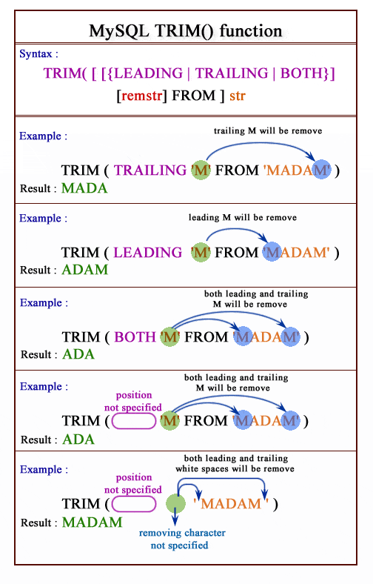

**IFNULL(expression1, expression2); takes two expressions and if the first expression is not NULL, it returns the first expression. Otherwise, it returns the second expression.**

e.g. **SELECT *, IFNULL(Comm, 0) FROM EMP;**

**LENGTH(**char) length in characters of specified string

**Remember -- you must put single quotes round all data items which are strings.**

**EXAMPLES OF STRING FUNCTIONS**

**SELECT SUBSTR(ename,1,4) FROM emp;**

**UPPER(dname)**

**SELECT UPPER('helen campbell') FROM dual;**

**LOWER(ename)**

**SELECT LOWER('Mr Donald Briffet') FROM dual;**

**STR_TO_DATE('12-12-92', '%d-%m-%Y ')**

**SELECT STR_TO_DATE('12-06-1996', ' %d-%m-%Y ') FROM dual;**

**LPAD(ename, 10,’ ’)**

**SELECT LPAD(ename,10,’ ’) FROM emp;**

**(pads the name out to 10 chars with spaces before)**

**RPAD(ename, 10,’ ’)**

**SELECT RPAD(ename,10, ’ ’) FROM emp;**

**(as above but with spaces after)**

**LTRIM(ename,' ')**

**SELECT LTRIM(ename,' ') FROM emp;**

**(removes spaces from before the name)**

**RTRIM(ename,' ')**

**SELECT RTRIM(ename,' ') FROM emp;**

**IFNULL(comm, 0)**

**SELECT IFNULL (comm,0) FROM emp;**

**(if an employee has no commission then 0 is displayed)**

**LENGTH(ename)**

**SELECT LENGTH ('Anderson') FROM dual;**

**NOTE You can also rename columns within the SQL statement**

**SELECT ename Employee FROM emp;**

**will output the present ename values with the heading Employee. Note that if the new name is a single word then double quotes are not needed.**

**ARITHMETIC FUNCTIONS**

**ABS(numeric)** absolute value of the number

**SELECT ABS(-15) “Absolute” FROM DUAL;**

**MOD(num1, num2)** returns the remainder when num1 is divided by num2

**SELECT MOD (7,5) “modulo” FROM DUAL;**

**ROUND(numeric[,d])** rounds the number to d decimal places, the rounding can occur to either side of the decimal point.

**SELECT ROUND (15.193,1) “round” FROM DUAL;**

**TRUNCATE(numeric[,d]])** truncates to d decimal places,

**SELECT TRUNCATE(15.79,1) “truncate” FROM DUAL;**

**CEIL(numeric)** rounds the number up to the nearest integer

**SELECT CEIL(10.6) FROM dual;**

**FLOOR(numeric)** truncates the number to the nearest integer

**SELECT FLOOR(10.6) FROM dual;**

**SQRT(numeric)** returns the square root of the number (returns NULL if the number is negative)

**SELECT SQRT(25) FROM dual;**

**TO_CHAR(numeric[,format])** converts a number to a character string in the specified format

**SELECT TO_CHAR(sysdate(),'DY') FROM dual;**

**SELECT TO_CHAR(sysdate(),'MONTH') FROM dual;**

**DATE_FORMAT(date,format) Cut and Paste date_format strings for MySQL**

**SELECT DATE_FORMAT(NOW(),'%Y-%m-%d %H:%i:%s')**

**SELECT DATE_FORMAT(NOW(),'%m')**

**Some more examples**

**SIGN(sal - comm)**

**SELECT SIGN(sal – 4 * comm) FROM emp;**

**ABS(sal - comm)**

**SELECT ABS(sal – 4*comm) FROM emp;**

**ROUND(sal,2)**

**SELECT ROUND(1234.5678,2) FROM dual;**

**TRUNCATE(comm, 3)**

**SELECT TRUNCATE(comm, 3) FROM emp;**

**GREATEST(sal, comm)**

**SELECT GREATEST(sal, comm) FROM emp;**

**DATE_FORMAT(date,format) Cut and Paste date_format strings for MySQL**

**SELECT DATE_FORMAT(NOW(),'%Y-%m-%d %H:%i:%s')**

**IT IS VERY IMPORTANT TO NOTE THAT IF ANY VARIABLE CONTAINS A NULL VALUE THEN ANY SQL STATEMENT INVOLVING ARITHMETIC WILL IGNORE IT**

**E.G.**

**SELECT ABS(SAL-COMM) FROM EMP;**

**will only produce results for employees who have a non-null commission (or salary)**

**AGGREGATE OR GROUPING FUNCTIONS**

**AVG**  **AVG ( [DISTINCT] Column** )

This function returns the average of the values in the argument.

The data type of the argument must be numeric, date/time or character. The data type of the result is the same as the input argument.

**DISTINCT** eliminates duplicates.

e.g. Find the total salary budget for each department, the average salary, the number of people in each department.

**SELECT emp.deptno, dname, SUM(sal), AVG(sal), COUNT(empno)**

**FROM emp, dept**

**WHERE emp.deptno = dept.deptno**

**GROUP BY emp.deptno, dname;**

**SELECT AVG(sal) “average” FROM emp;**

**COUNT COUNT (*)**

**(DISTINCT**  expression)

This function returns a count of items.

` **COUNT(*)** always returns the number of rows in the table, rows that contain null values are included.

**COUNT(column-name)** returns the number of column values.

**COUNT(DISTINCT column-name)** filters out duplicate column values.

e.g. How many employees are in each department of the EMP table?

**SELECT COUNT(*) FROM emp**

**GROUP BY deptno;**

**SELECT COUNT(DISTINCT job) "Jobs" FROM emp**;

NOTE - the “” round Jobs is superfluous here, but must be used if the column heading is more than one word.

**MAX SELECT MAX(sal) FROM emp;**

**MIN SELECT MIN(sal) FROM emp;**

These functions returns the maximum or minimum value in the argument, which is a set of column values.

e.g. Find the highest and lowest salary in department 10.

**SELECT MAX(sal), MIN(sal)**

**FROM emp**

**WHERE deptno = 10;**

**SUM SUM(ALL expression)**

This function returns the sum of the values in the argument.

**SELECT SUM(sal + comm) FROM emp**

**WHERE job = 'SALESMAN';**

**NOTE - because Comm can contain a NULL value, be warned that if it does, SQL cannot evaluate it as an arithmetic expression and will ignore that record. Thus the above will obtain a sum for all Salesmen because they all get commission.**

**SELECT SUM(sal + Comm) FROM emp;**

**will try to do the same sum for all staff but since only salesmen get commission, all other employees will have null commission, their records will be ignored, and the end result will be the same.**

NB these functions work down the columns they DO NOT act across the rows.

**IF YOU INCLUDE GROUP FUNCTIONS IN A SELECT COMMAND YOU MAY NOT SELECT INDIVIDUAL RESULTS AS WELL.**

For example, a command that begins SELECT ENAME, AVG(sal) is invalid.

ENAME has a value for each row selected while AVG(sal) has a single value for the whole query. If you use such a command SQL will display an error message.

There are two exceptions to this rule.:-

You can display individual results based on a group function in a subquery, or

group results based on individual selections in a subquery.

**NOTE** - If an arithmetic expression encounters a Null value then that record is ignored

e.g. SELECT SUM(SAL+COMM)

can only do the addition where COMM is not null. Similarly

SELECT AVG(SAL+COMM) will only divide the total by the number of times it has been able to do the addition (and not a count of all employees).

**Summarising Several Groups of Rows.**

Suppose you want to know the average salary of the employees in each department, you could enter several separate AVG(SAL) queries, one per department, but you can get the same information with a single query by using the GROUP BY clause. The GROUP BY clause divides a table into groups of rows so that the rows in each group have the same value in a specified column. (See later notes for more details about GROUP BY clause.)

To list the average salary in each department.

**SELECT DEPTNO, AVG(sal) FROM emp**

**GROUP BY deptno;**

In this example, the **GROUP BY deptno** clause divides all the employees into groups on their department number, the group function **AVG(sal**) is then applied to the rows in each group. This is a powerful function and would take many lines of code in a normal procedural language.

**EXERCISES 3 FUNCTIONS**

1 Find how many employees have a title of manager without listing them.

2 Compute the average annual salary plus commission for all salesmen

3 Find the highest and lowest salaries and the difference between them (single SELECT statement)

4 Find the number of characters in the longest department name

5 Count the number of people in department 30 who receive a salary and the number of people who receive a commission (single statement).

6 List the average commission of employees who receive a commission, and the average commission of all employees (assume employees who do not receive a commission attract zero commission)

7 List the average salary of employees that receive a salary, the average commission of employees that receive a commission, the average salary plus commission of only those employees that receive a commission and the average salary plus commission of all employees including those that do not receive a commission. (single statement)

8 Compute the daily and hourly salary for employees in department 30, round to the nearest penny. Assume there are 22 working days in a month and 8 working hours in a day.

9 Issue the same query as the previous one except that this time truncate (TRUNC) to the nearest penny rather than round.

**DATE FUNCTIONS**

Some important Date funcitons are listed below:

1. DATE_FORMAT (date,format)   
It presents a date in the specified format

SELECT DATE_FORMAT(now(), '%d-%m-%Y');  
See detailed instruction of DATE_FORMAT attached in the following pages

2. DATE_ADD (start_date, INTERVAL expr unit)   
or start_date + INTERVAL expr unit

It adds an interval to a DATE or DATETIME. Specifically, start_date is a starting DATE or DATETIME value; INTERVAL expr unit is an interval value to be added to the starting date value.

**SELECT DATE_ADD(now(), INTERVAL 1 day);**

|  |  |
| --- | --- |
| **Unit** | **Expression** |
| DAY | DAYS |
| DAY_HOUR | ‘DAYS HOURS’ |
| DAY_MICROSECOND | ‘DAYS HOURS:MINUTES:SECONDS.MICROSECONDS’ |
| DAY_MINUTE | ‘DAYS HOURS:MINUTES’ |
| DAY_SECOND | ‘DAYS HOURS:MINUTES:SECONDS’ |
| HOUR | HOURS |
| HOUR_MICROSECOND | ‘HOURS:MINUTES:SECONDS.MICROSECONDS’ |
| HOUR_MINUTE | ‘HOURS:MINUTES’ |
| HOUR_SECOND | ‘HOURS:MINUTES:SECONDS’ |
| MICROSECOND | MICROSECONDS |
| MINUTE | MINUTES |
| MINUTE_MICROSECOND | ‘MINUTES:SECONDS.MICROSECONDS’ |
| MINUTE_SECOND | ‘MINUTES:SECONDS’ |
| MONTH | MONTHS |
| QUARTER | QUARTERS |
| SECOND | SECONDS |
| SECOND_MICROSECOND | ‘SECONDS.MICROSECONDS’ |
| WEEK | WEEKS |
| YEAR | YEARS |
| YEAR_MONTH | ‘YEARS-MONTHS’ |

3. TIMESTAMPDIFF(unit,datetime_expr1,datetime_expr2)

It returns expr1 − expr2 expressed as a value in unit from one date to the other. expr1 and expr2 are date or date-and-time expressions.

select TIMESTAMPDIFF(Day, now(), HIREDATE) from emp;

select TIMESTAMPDIFF(Month, now(), HIREDATE) from emp;

select TIMESTAMPDIFF(Year, now(), HIREDATE) from emp;

4. LAST_DAY(date)

It takes a date or datetime value and returns the corresponding value for the last day of the month. Returns NULL if the argument is invalid.

SELECT LAST_DAY(NOW());

5. DATE(expr)

It extracts the date part of the date or datetime expression expr.

SELECT DATE('2003-12-31 01:02:03');

Similar functions include Time(), Day(), Month(), Year(), etc.

6. DATE_FORMAT(date,format)

The DATE_FORMAT function accepts two arguments:

date : is a valid date value that you want to format

format : is a format string that consists of predefined specifiers. Each specifier is preceded by a percentage character ( % ). See the table below for a list of predefined specifiers.

The following are some commonly used date format strings:

| DATE_FORMAT string | Formatted date |
| --- | --- |
| %Y-%m-%d | 7/4/2019 |
| %e/%c/%Y | 4/7/2019 |
| %c/%e/%Y | 7/4/2019 |
| %d/%m/%Y | 4/7/2019 |
| %m/%d/%Y | 7/4/2019 |
| %e/%c/%Y %H:%i | 4/7/2019 11:20 |
| %c/%e/%Y %H:%i | 7/4/2019 11:20 |
| %d/%m/%Y %H:%i | 4/7/2019 11:20 |
| %m/%d/%Y %H:%i | 7/4/2019 11:20 |
| %e/%c/%Y %T | 4/7/2019 11:20 |
| %c/%e/%Y %T | 7/4/2019 11:20 |
| %d/%m/%Y %T | 4/7/2019 11:20 |
| %m/%d/%Y %T | 7/4/2019 11:20 |
| %a %D %b %Y | Thu 4th Jul 2019 |
| %a %D %b %Y %H:%i | Thu 4th Jul 2019 11:20 |
| %a %D %b %Y %T | Thu 4th Jul 2019 11:20:05 |
| %a %b %e %Y | Thu Jul 4 2019 |
| %a %b %e %Y %H:%i | Thu Jul 4 2019 11:20 |
| %a %b %e %Y %T | Thu Jul 4 2019 11:20:05 |
| %W %D %M %Y | Thursday 4th July 2019 |
| %W %D %M %Y %H:%i | Thursday 4th July 2019 11:20 |
| %W %D %M %Y %T | Thursday 4th July 2019 11:20:05 |
| %l:%i %p %b %e, %Y | 7/4/2019 11:20 |
| %M %e, %Y | 4-Jul-19 |
| %a, %d %b %Y %T | Thu, 04 Jul 2019 11:20:05 |

**EXERCISES 4 DATES**

1 Select the name, job, and date of hire of the employees in department 20. (Format the HIREDATE column to MM/DD/YY)

2 Then format the HIREDATE column into DoW (day of the week), Day (day of the month), MONTH (name of the month) and YYYY(year)

1. Which employees were hired in April?

4 Which employees were hired on a Tuesday?

5 Are there any employees who have worked more than 30 years for the company?

6 Show the weekday of the first day of the month in which each employee was hired. (plus their names)

7 Show details of employee hiredates and the date of their first payday.

(Paydays occur on the last Friday of each month) (plus their names)

8 Refine your answer to 7 such that it works even if an employee is hired after the last Friday of the month (cf Martin)

**THE GROUP BY CLAUSE**

The **GROUP BY** clause is used to split rows in a table into groups or subsets. Summary calculations may then be performed on those groups of records. The grouping is performed on the basis of matching values within a column (or set of columns)

Only one line of output is presented for each group.

**SELECT deptno, AVG(sal) FROM emp**

**GROUP BY deptno;**

This will present average salaries for each deptno group along with the value of deptno within each group. Note it is important to **SELECT** the column by which you are grouping, in order to 'label' your calculated values. Whenever Oracle performs a GROUP BY it also sorts the groups on the basis of the grouping column.

**RULES FOR GROUP BY**

**1** The **SELECT** list may contain only aggregate functions (e.g MAX(sal), COUNT(empno)) and items appearing in the group by clause.

2 The **GROUP BY** clause must be specified after any **WHERE** clause.

3 It is usual to **SELECT** columns which are specified in the **GROUP BY** clause

4 The default 'group' is the whole set of records in the table. Thus any aggregate functions will apply to the whole table if no **GROUP BY** clause is specified

**SELECT MAX(sal) FROM emp;**

will output one value for the maximum salary over all the employees but

**SELECT ename, MAX(sal) FROM emp;**

will cause an error because the table is not being grouped by ename (if you did group by ename you would see a maximum salary for each employee

**SELECT job, MIN(sal) FROM emp**

**GROUP BY job;**

will show a minimum salary for each job.

If it has a **WHERE** clause place the **GROUP BY** clause after the **WHERE** clause.

To find the average annual salary of the non-managerial staff in each department.

**SELECT deptno, AVG(sal) FROM emp**

**WHERE job NOT IN ('MANAGER', 'PRESIDENT')**

**GROUP BY deptno;**

You may divide the rows of a table into groups based on values in more than one column, for example, to divide all employees into groups by department and job, specify both **DEPTNO** and **JOB** in the **GROUP BY** clause.

To count the employees and calculate the average annual salary for each job group in each department.

**SELECT deptno, job, COUNT(*), AVG(sal)**

**FROM emp**

**GROUP BY deptno, job;**

**SELECT deptno,MAX(sal) FROM emp**

**WHERE job != 'PRESIDENT'**

**GROUP BY deptno;**

This shows the departmental maximums involving all employees excluding the president.

**THE HAVING CLAUSE**

Just as you can select individual rows to display with a **WHERE** clause you can select groups to display with a **HAVING** clause. Place the **HAVING** clause in your query after the **GROUP BY** clause.

A **HAVING** clause compares some property of the group with a constant value. If a group satisfies the condition in the **HAVING** clause it is included in the query result.

You want to list the average annual salary for all job groups with more than two employees.

**SELECT job, COUNT(*), AVG(sal) FROM emp**

**GROUP BY job**

**HAVING COUNT(*) > 2;**

The **HAVING** clause compares COUNT(*) , a property of the group, to the constant value 2.

The **HAVING** clause must be specified after the **WHERE** clause and before any **ORDER BY** clause in the SQL statement. It may appear either before or after its associated **GROUP BY** clause, but it is normal to place it after the **GROUP BY**.

**SELECT deptno, job, COUNT(empno), SUM(sal)**

**FROM emp**

**WHERE hiredate > '01-JAN-90'**

**GROUP BY deptno, job**

**HAVING COUNT(empno)>2**

**ORDER BY deptno DESC, JOB;**

Note the use of the aggregate function in the having clause. It is important to realize that aggregate functions are not allowed in **WHERE** clauses, because **WHERE** applies only to individual records - not groups of records. The **HAVING** clause is designed to work with grouped sets of records and hence can accommodate conditions based on aggregated values.

You may include both a **WHERE** clause and a **HAVING** clause in a query, if you do SQL proceeds in this order:

1. It applies the **WHERE** clause to select rows.

2. It forms the groups and calculates group functions.

3. It applies the **HAVING** clause to select groups.

To list all the departments with at least two clerks.

**SELECT deptno FROM emp**

**WHERE job = 'CLERK'**

**GROUP BY deptno**

**HAVING COUNT(*) >= 2;**

To select groups based on comparisons with another group, include a subquery in the **HAVING** clause.

To list job groups whose average salary exceeds that of all the managers

S**ELECT job, AVG(sal) FROM emp**

**GROUP BY job**

**HAVING AVG(sal) >**

**(SELECT AVG(sal) FROM emp**

**WHERE job = 'MANAGER');**

**EXERCISES 5 GROUP BY & HAVING**

1 List the department number and average salary of each department.

2 Divide all employees into groups by department and by job within department. Count the employees in each group and compute each group's average annual salary.

3 Issue the same query as above except list the department name rather than the department number.

4 List the average annual salary for all job groups having more than 2 employees in the group.

5 Find all departments with an average commission greater than 25% of average salary.

6 Find each department's average annual salary for all its employees except the managers and the president.

**SUBQUERIES AND NESTED SUBQUERIES**

A **SELECT** command may be incorporated into another **SQL** command such as **SELECT** or **UPDATE.** Such a **SELECT** command is called a subquery. The rows selected by the subquery are not displayed; instead they are fed back into the surrounding **SQL** command in one of the following ways:

If the subquery is used on the right side of a logical expression or a set expression, it must return a single value or a single column of values. The value(s) are compared to the value(s) on the left side of the expression in the manner specified by the operator connecting the two sides.

If the subquery is used to specify the values in a **CREATE, INSERT**, or **UPDATE** command, it must return one value for each column to be updated. The value(s) are used to update the specified row(s).

The **ORDER BY** and **FOR UPDATE** clauses may not be used in a subquery.

The **WHERE** clause of one query may contain another query (called a nested subquery).

**SELECT ename FROM emp**

**WHERE job = (SELECT job FROM emp**

**WHERE ename = 'JONES')**

**AND ename != 'JONES';**

The subquery must be enclosed in brackets and the values which are compared across the outer and subquery must be of the same datatype.

Subqueries are often used to perform stepwise processing.

Finding the person with the highest salary may be done in two steps.

1. Find the maximum salary

2. Find the person whose salary is equal to the maximum salary

**SELECT ename, sal FROM emp**

**WHERE sal = (SELECT MAX(sal) FROM emp);**

The nested query is performed in step 1 and its result is used in step 2 as the outer query is processed.

Subqueries can be nested to any number of levels, but in practical terms 3 is usually the maximum used.

SELECT.......

FROM....

WHERE.....(SELECT.....

FROM......

WHERE.....(SELECT....

FROM...

WHERE....

Generally the subquery is executed first, and SQL compares select-fields in the 'outer' query with the results produced by the subquery.

It is possible to have 16 sub-queries at each level of nesting.

SELECT select-list

FROM .........

WHERE (select-field1, select-field2,.........)

comparison operator

(SELECT select-list2

FROM........

WHERE (..........))

comparison operator

(SELECT select-list

FROM ......

WHERE (.........))

The comparisons can be any of the usual comparisons :--

= != > >= < <= LIKE (see previous notes).

If the subquery returns more than one value, one of the following words should follow the comparison operator:

ALL -- the comparison must be true for all returned values.

ANY -- The comparison need only be true for one returned value.

IN may be used in place of = ANY.

NOT IN may be used in place of != ALL.

More than one select-field may be used, but, in this case, only one test for equality may be used. Parentheses must be used to enclose the SELECT list of a subquery when it contains more than one column.

Finding the department which has the highest total salary bill could be done in two steps.

1 Find the highest total salary paid by a department.

2 Find the department which has a salary bill which matches the value given in part 1.

**SELECT deptno, SUM(sal) FROM emp**

**GROUP BY deptno**

**HAVING SUM(sal) = (select MAX(sum_sal)**

**from (SELECT deptno, SUM(sal) as sum_sal**

**FROM emp GROUP BY deptno)**

**as sum_sal_t);**

**or**

**SELECT deptno, SUM(sal) FROM emp**

**GROUP BY deptno**

**HAVING SUM(sal) >= All(SELECT SUM(sal)**

**FROM emp GROUP BY deptno);**

Find the employees that earn more than at least one employee in department 30

**SELECT sal, job, ename, deptno FROM emp**

**WHERE sal > ANY**

**( SELECT sal FROM emp**

**WHERE deptno = 30)**

**ORDER BY sal DESC;**

The '=' operator should not be used if the subquery may return more than one value.

An error message will be produced.

**' Subquery returns more than 1 row'.**

To avoid this problem use the keyword '**IN'.**

**SELECT ename, sal, deptno, job FROM emp**

**WHERE empno IN (SELECT mgr FROM emp);**

**Exists Operator.**

In order to ensure that the subquery returns at least one row, the **EXISTS** operator can be used. The conditional expression **EXISTS** (i.e. the subquery) is TRUE if the subquery returns at least one row, and false otherwise.

Display data about employees who have at least one other employee reporting to them

**SELECT job, ename, empno, deptno FROM emp X**

**WHERE EXISTS**

**(SELECT * FROM emp**

**WHERE X.empno = mgr)**

**ORDER BY empno;**

This is not the same as asking for all the managers, since some of the rows returned are not managers, but do have employees working for them

**Multiple Conditions.**

In the following example we compare both the department number and the salary. Where multiple columns are being compared and they must be enclosed in parentheses. The columns should be specified in the same order as their counterparts in the subquery.

**SELECT ename, sal, deptno, job FROM emp**

**WHERE (deptno, sal) IN ( SELECT deptno, MIN(sal)**

**FROM emp**

**GROUP BY deptno);**

**Synchronising a repeating subquery with a main query**

Depending on the structure of a subquery, it can operate in different ways. In the previous examples, the subquery was executed once and the resulting value was substituted into the WHERE clause of the main query.

In some cases, the result of the subquery should be dependent on values in the outer query. This is termed a 'synchronised' or 'correlated' subquery.

SELECT select-list FROM table1 label1 [.................]

WHERE (select-field[.........] )

comparison operator

(SELECT select-list2 FROM .........

WHERE select-field comparison operator label1.select-field)

The important point is the use of the 'table label' in the outer query. This allows the execution of the subquery for each 'candidate row' (row that may be selected) in the outer query, and produce a subquery result depending on the data in the outer query.

Find the department number, name and salary of the employees who earn more than the average salary in their department.

**SELECT deptno, ename, sal FROM emp X**

**WHERE sal >**

**(SELECT AVG(sal) FROM emp**

**WHERE X.deptno = deptno)**

**ORDER BY deptno;**

**EXERCISES 6 SUB QUERIES.**

1 List the name and job of employees who have the same job as Jones.

2 Find all the employees in Department 10 that have a job that is the same as anyone in department 30.

3 List the name, job, and department of employees who have the same job as Jones or a salary greater than or equal to Ford.

4 Find all employees in department 10 that have a job that is the same as anyone in the Sales department

5 Find the employees located in Liverpool who have the same job as Allen. Return the results in alphabetical order by employee name.

6 Find all the employees that earn more than the average salary of employees in their department.

7 Find all the employees that earn more than JONES, using temporary labels to abbreviate table names.

**THE DATA MANIPULATION LANGUAGE**

This is the section of SQL which handles data manipulation i.e. inserting, updating and deleting rows in tables It consists of three basic statements

**INSERT allows insertion of records into a table**

**UPDATE updates existing rows in a table**

**DELETE removes unwanted rows from a table**

These statements are incorporated into what is known as a transaction.

**INSERTing rows into a table:-**

INSERT INTO <tablename> (fieldname1, fieldname2, ........)

VALUES (value1, value2,........);

This format allows insertion of ONE complete row into the table. The values in the list **must** be in the same order as the columns in the table and there must be a value for each column

i.e.

**INSERT INTO emp (empno, ename, job, mgr, hiredate, sal, comm, deptno)**

**VALUES(7500, 'CAMPBELL', 'ANALYST', 7566, '30-OCT-1992', 24500, 0, 40);**

If you do not have values for all the columns, a list of columns may be specified and values provided in the same order as the specified columns

**INSERT INTO emp(empno, ename, hiredate, deptno)**

**VALUES(7888,'PITT','30-MAR-92', 30);**

All unspecified columns will be set to NULL.

NB only one row at a time can be inserted using the above forms of the insert statement.

**UPDATING TABLES**

The general form is to update one or more rows of a table where a condition (possibly a subquery) is true.

**UPDATE emp SET comm = 0;**

will give all employees zero commission.

To give a 15% raise to all Analysts and Clerks in department 20 could use;

**UPDATE emp**

**SET sal = sal* 1.15**

**WHERE (job = 'ANALYST' OR job = 'CLERK')**

**AND deptno = 20;**

The following **SELECT** shows how the two forms of **SET**, may be mixed in a single command, **SET deptno**... sets the updated rows' **deptno** to the value of **deptno** in the row of the table **dept** where the value of **loc** is Dallas. (**sal, comm**) .... sets **sal** and **comm** to values returned by group expressions in a subquery. **WHERE.**.. states that the updated rows are to be those whose **deptno** has a value found in the set of rows where the value of **loc** is Dallas or Detroit.

**UPDATE emp A**

**SET deptno = (SELECT deptno FROM dept**

**WHERE loc = 'PRESTON'),**

**(sal, comm) =**

**(SELECT 1.1*AVG(sal),1.5*AVG(comm)**

**FROM emp B**

**WHERE A.deptno = B.deptno)**

**WHERE deptno IN**

**(SELECT deptno FROM dept**

**WHERE loc = 'LIVERPOOL'**

**OR loc = 'LONDON');**

If a WHERE clause is not used to limit the number of rows updated every row in the table will be updated to your specified value.

**DELETING FROM TABLES**

The general form is:-

**DELETE FROM <tablename> WHERE [conditional statement];**

If **WHERE** condition is specified all rows for which the condition is true are deleted.

i.e. To remove from EMP all sales staff who made less than 100 commission last month enter:

**DELETE FROM emp**

**WHERE job = 'SALESMAN'**

**AND comm < 100;**

To delete everything in a table :

**DELETE FROM <tablename>;**

This command does not ask for confirmation! Always make sure you use a WHERE clause in any DELETE statement unless you really want to wipe the entire table!

When a table is wiped, no space is freed up in the Oracle database for use by other tables. The space used by a table does not dynamically shrink when data is deleted from the table.

**THE DATA DEFINITION LANGUAGE**

DDL statements change the structure of the database. There are three basic commands:-

**CREATE used to create new objects (tables, views, etc.) in the database**

**ALTER used to change the structure of an existing object**

**DROP used to remove the object from the database, (all its data plus any reference to it in the data dictionary)**

**TO CREATE A NEW TABLE** use the CREATE TABLE statement

**CREATE TABLE** <tablename>

(fieldname data type,

fieldname data type,

. );

Fieldname may be any alphanumeric name starting with an alphabetic character. The name may also contain '$' '-_' '#' '@' (maximum 30 characters)

Valid datatypes are listed after this section.

E.G. :-

**CREATE TABLE emp**

**(empno NUMERIC NOT NULL,**

**ename CHAR(10) ,**

**job CHAR(9),**

**mgr NUMERIC (4),**

**hiredate DATE ,**

**sal NUMERIC (10,2),**

**comm NUMERIC (9,0) ,**

**deptno NUMERIC (4) NOT NULL);**

Note that NOT NULL is specified for the empno column. This will be used as the primary key.

When a table is created you may specify criteria for its storage ( such as initial space allocation). If the storage clause is not used SQL*PLUS will use the current defaults

SQL allows far more complex create statements

**CREATE TABLE emp**

**(empno NUMERIC NOT NULL,**

**ename CHAR(10) NOT NULL,**

**job CHAR(9),**

**mgr NUMERIC REFERENCES emp(empno),**

**sal NUMERIC(10,2),**

**comm NUMERIC(9,0) DEFAULT NULL,**

**deptno NUMERIC(2) NOT NULL REFERENCES dept(deptno),**

**Primary key(empno),**

**CHECK(sal > 500)**

**)**

Here the primary key is specified as are some integrity checks and simple validation. i.e.

mgr number must exist as an empno

deptno must exist in the dept table

Note this means that you must be very careful about the order in which you create the tables.

Can create **UNIQUE INDEX** to ensure the **PRIMARY KEY** does not contain duplicate values.

**CREATE [ UNIQUE] INDEX <indexname> ON <tablename> (index key);**

every index must follow the standard ORACLE naming rules and must have a distinct name with respect to all other objects owned by a single user.

Include the name s of the tables and columns that comprise the index within the index name.

Preface the index name with I

Separate the table and column names with punctuation.

e.g. **CREATE UNIQUE INDEX I_EMP$EMPNO ON EMP (EMPNO);**

**CREATE UNIQUE INDEX I_EMP$ENAME ON EMP (ENAME);**

you could not have a unique index on this field as more than one person could have the same name.

this format will also work on multiple keys.

**CREATE INDEX <indexname> ON <tablename>(fieldname1, fieldname2);**

NB All index names must be unique!

**DROP INDEX <**indexname>; allows you to remove an unwanted index you can only drop indexes that you have created

**SQL DATA TYPES**

**CHAR** (size) consists of upper and lower case letters, numbers and special characters (+,-,%,$,&, etc.) size the maximum length, in characters, of the column. May not be larger than 255.

**VARCHAR(**size) Variable length character string data type. Only stores the actual length of the data field, does not space fill to size specified. size must be specified.

**LONG**  Character data of variable length up to 65,535 characters. Only one long column per table.

**NUMERIC** Number values consisting of digits 0 -- 9, with an Values may be 38 digits wide.

**NUMERIC**(w,d) Number values with decimal places specified

**DECIMAL**(w,d) Stores numbers with up to 22 decimal digits.

W - specifies the total number of digits

d - specifies the number of decimal places.

(i.e. decimal (4,2) will allow a max. number of 99.99 to be inserted.)

**INTEGER** Stores numbers with 10 or fewer digits, digits to the right of the decimal point are truncated.

**SMALLINT** Stores digits with 5 or fewer digits.

**DATE**  Date values - usual form dd-mmm-yy i.e. 30-OCT-98

**ALTERing the table structure**

To modify the definition or structure of a table, use **ALTER TABLE** command

To add a new column

**ALTER TABLE <tablename>**

**ADD (column_name datatype);**

**ALTER TABLE emp**

**ADD gender CHAR(1);**

To change the definition of an existing column.

**ALTER TABLE <tablename>**

**MODIFY (column_name datatype);**

**ALTER TABLE emp**

**MODIFY deptno NUMERIC(6);**

You cannot 'drop' or 'delete' a column using ALTER.

There is no direct support in SQL for removing columns from a table!

You may not rename a column using ALTER.

Again there is no direct support for this in SQL

The use of the ALTER TABLE statement to change column definitions is restricted to the following:-

1 If the table does not contain any data, you may

- add extra NULL or NOT NULL columns

- change the datatypes of an existing column

- alter an existing column to be NULL or NOT NULL

- make the width of the column smaller or larger

2 If the table contains rows, but there are no values in the column in question

- make the column width smaller or larger

- change the datatype

3 If the column already has data values

- make the column width larger(not smaller)

- force the column to be NOT NULL if there are no NULLs

already present in the column.

**DROPping objects from the database**

The DROP statement may be used to remove entire unwanted objects from the database. It frees up any space they were occupying and removes all references to them from the data dictionary. (Only the creator of the table can DROP it)

**DROP TABLE <tablename>;**

will remove the specified table (with its contents ) from the database.

When you drop a table, SQL automatically drops indexes for the table, synonyms for the table's name and privileges granted on the table. Views that refer to the table are not dropped, but become invalid. You should drop them or redefine them, or (re)define other tables in such a way that the views become valid again.

INDEX It is possible for two indexes from different tables to have the same name. In that case, when you drop one of the indexes you must specify ON table to identify the index you want to drop.

**DROP INDEX ind1;**

Remember that this statement is very severe and should be used with extreme caution.

No confirmation is requested by Oracle in order to perform this operation

Oracle issues an implicit command both before and after it processes to DROP command. This means you cannot roll it back.

You cannot use the DROP command to DROP columns, deleting columns from tables can not be done directly, the following can be used

**To delete the column loc from the dept table**

**1** Create a new table which is the image of the dept table excluding the LOC column

CREATE TABLE newdept

AS SELECT deptno, dname FROM dept;

this produces a table containing all the data for the deptno and dname which already exists in the dept table. Column headings will default to those in the dept table.

2 Now drop the old table

DROP TABLE dept

3 Rename the new table to the old table name

RENAME newdept TO dept

EXEC sp_rename 'emp', 'emp10'

**VIEWS**

Views can be regarded as windows through which users may see data stored in database tables. They have a number of attractive features:-

(i) they do not own any data of their own

hence they take up virtually no space in the database (only that required for their definition in the relevant data dictionary)

(ii) they are automatically activated when the user references them in an SQL statement

this means they will always reflect the current state of the database

(iii) they may be simple or arbitrarily complex

views may be based on single or multiple tables and may also reference other views

views may be tailored to suit user requirements and make the users task easier (e.g. avoid specification of complex joins)

simple views are based on a single table and only contain columns which are directly stored in the table in question

(iv) views are merely stored SQL statements

hence they can be defined using familiar SQL constructs

(v) may be treated as tables in SQL queries

almost 100% compatible with table usage

(vi) can be used to implement row level security within SQL*PLUS

the GRANT statement does not provide this functionality

(vii) may be used to implement integrity (including referential ) checks

SQL uses constraints to perform this function

(viii) useful in providing a level of data independence for application programs

their use allows the structure of the database to change with minimal effect on users and application programs.

**VIEW MANAGEMENT**

View definitions may be seen using the following dictionary views

USER_VIEWS ALL_VIEWS DBA_VIEWS

these show the viewnames along with the full view definitions.

Views may be created using the **CREATE VIEW<viewname>** command (no storage definition is required) They may be dropped with the **DROP VIEW<viewname>** command

Views may not be altered, they are essentially stored SQL statements, so for complex views it is advisable to save their definitions in a command file so that they can be changed more easily if needed.

When a table is dropped any views built on it become inaccessible.

The use of views can present a performance overhead, mainly in increased parse times.

**CREATEing Views**

The **CREATE VIEW** command allows you to create a view by specifying a standard SQL query

**CREATE VIEW <VIEWNAME> [(col1, col2,...)]**

**AS SELECT <some statement to present the required data>**

**[WITH CHECK OPTION];**

The specification of column headings in the view is normally optional and they will obviously correspond on a one to one basis with items in the SELECT list of the query.

To create a simple view on the emp table:-

**CREATE VIEW dept30**

**AS SELECT ename, sal, comm FROM emp**

**WHERE deptno = 30;**

At this point Mysql will reply with 'View Created'.

The view can be used and referenced as you would a normal mysql table-

**SELECT ename, sal FROM dept30**

**WHERE comm IS NOT NULL;**

Complex views can be used to make life easier for the user and also to prevent virtual columns (columns that do not exist in the base table)

**CREATE VIEW total_comp (employee, job, salary, commission, annual_sal, total)**

**AS SELECT ename, job, sal, NVL(comm,0), sal*12, sal*12+NVL(comm,0)**

**FROM emp;**

Views which contain virtual columns MUST have their own column headings specified. In the above example annual_sal represents sal*12 from the base table.

Views cannot contain an **ORDER BY** clause this must be specified in the normal **SELECT** statement

**SELECT * FROM dept30**

**ORDER BY sal;**

**DATA MANIPULATION of Views**

It is tempting to make heavy use of views, however some serious problems are likely to be encountered when attempting to manipulate data through views.

Consider the following view definition:-

**CREATE VIEW summary**

**AS SELECT deptno AVG(sal)**

**FROM emp**

**GROUP BY deptno;**

This view contains an aggregate function which makes all data seen through the view non updatable.

Views on more than one table suffer similar restrictions.

**CREATE VIEW deptemp**

**AS SELECT empno, ename, hiredate, sal, comm, deptno, dname, loc**

**FROM emp**

**WHERE emp.deptno = dept.deptno;**

The output from this view would look like :-

**EMPNO ENAME HIREDATE SAL COMM DEPTNO DNAME LOC**

**7777 COX 11-APR-92 2000 500 30 SALES LIVERPOOL**

If you tried to delete Cox's details from the view, Oracle would try to translate the delete command into two separate deletes on the two base tables, this could cause problems as we could find the remaining employees in Cox's department would have no corresponding department record in the department table.

All DML operations on views based on more than one table are disabled.

**UPDATEing Views**

The Rules

1 Views containing GROUPed sets of data:

no DML is allowed on any column in the view

2 Views based on the join of one or more tables (or views)

no DML is allowed on any column in the view

3 Views containing virtual columns

updates allowed on all but the virtual columns

delete operations are unrestricted

inserts are allowed if ALL not null columns are specified and no attempt is made to insert a value in any of the virtual column(s)

E.G. given the following view

CREATE VIEW virtualcols

AS SELECT empno, ename, sal, comm, sal + comm, total

FROM emp;

The following statements are **legal**

**UPDATE virtualcols SET sal =9999 WHERE empno = 7934;**

**INSERT INTO virtualcols VALUES(7777,'COX',8888,1111);**

The following statements are **illegal**

**UPDATE virtualcols SET total = 9999 WHERE empno = 7934;**

**INSERT INTO virtualcols VALUES(7777,'COX',8888,1111,9999);**

4 Simple views which do not possess ALL of the NOT NULL columns

no INSERTion of rows is possible ( only updates and deletes)

5 Views containing the WITH CHECK OPTION

Updates are restricted to those which result in data which still complies with the check (data migration is prevented)

**EXERCISES 7 Data Manipulation**

1 Create a new table called loans with columns named LNO NUMERIC (3), EMPNO NUMERIC (4), TYPE CHAR(1), AMNT NUMERIC (8,2)

2 Insert the following data

LNO EMPNO TYPE AMNT

23 7499 M 20000.00

42 7499 C 2000.00

65 7844 M 3564.00

3 Check that you have created 3 new records in Loans

4 The Loans table must be altered to include another column OUTST NUMERIC(8,2)

5 Add 10% interest to all M type loans

6 Remove all loans less than £3000.00

7 Change the name of loans table to accounts

8 Change the name of column LNO to LOANNO

9 Create a view for use by personnel in department 30 showing employee name, number, job and hiredate

10 Use the view to show employees in department 30 having jobs which are not salesman

11 Create a view which shows summary information for each department.

**SET OPERATORS**

**UNION** returns all distinct rows returned by *either* of the queries it applies to

**INTERSECT** returns all rows returned by *both* of the queries it applies to

**MINUS** returns all rows returned by the *preceding* query, but not by the following query

other operators are **JOIN**

**THE UNION OPERATOR**

this is a more generalised form of '**OR'**  it allows the result from two (or more ) queries to be returned as a single set.

e.g. Finding details of people who earn the same salary as Scott or Ward can be achieved using an OR construct as follows :-

**SELECT ename, job, sal FROM emp**

**WHERE sal IN**

**(SELECT sal FROM emp**

**WHERE ename = 'SCOTT'**

**OR ename = 'WARD');**

**BUT**  if Scott and Ward are in different tables a union construct is necessary

**SELECT ename, job, sal FROM emp**

**WHERE sal IN**

**(SELECT sal FROM emp**

**WHERE ename ='SCOTT'**

**UNION**

**SELECT sal FROM emp2**

**WHERE ename ='WARD');**

**USE OF INTERSECT**

This is a more general form of **AND**

**SELECT job FROM emp**

**WHERE sal >2000**

**INTERSECT**

**SELECT job FROM shopfloordetails;**

**USE OF MINUS**

this is sometimes called DIFFERENCE

**SELECT deptno, dname, loc FROM dept**

**WHERE deptno IN**

**(SELECT deptno FROM dept [first]**

**MINUS**

**SELECT deptno FROM emp); [second]**

**MINUS** returns the rows from the first query which are not also returned by the second query.

**THE ANY OPERATOR**

Find all employees who earn more than **any** employee in department 30

**SELECT sal, job, ename, deptno FROM emp**

**WHERE sal > ANY (SELECT sal FROM emp**

**WHERE deptno = 30);**

Can be rewritten using the **'MIN'** aggregate function

**SELECT sal, job, ename, deptno FROM emp**

**WHERE sal> (SELECT MIN(sal) FROM emp**

**WHERE deptno = 30);**

The ANY construct is almost entirely redundant

(=ANY performs the same function as IN)

**THE ALL OPERATOR**

To display information about employees who earn more than all employees in department 30

**SELECT sal, job, ename, deptno FROM emp**

**WHERE sal > ALL (SELECT sal FROM emp**

**WHERE deptno = 30);**

Can be rewritten using the '**MAX'**  aggregate function

**SELECT sal, job, ename, deptno FROM emp**

**WHERE sal > (SELECT MAX(sal) FROM emp**

**WHERE deptno = 30);**

**LOGICAL OPERATORS**

= equal to

!= not equal to

<> not equal to

> greater than

>= greater than or equal to

< less than

<= less than or equal to

ALL modifies the action of a condition to apply to all members of a list of values

ANY modifies the action of a condition to apply to any member of a list of values

[ NOT] BETWEEN ...... AND...... greater than or equal to one value and less than or equal to another

EXISTS Evaluates true if the following subquery returns at least one row

[NOT] IN equal to any member of the set of values

IS [NOT] NULL tests for null